

Ysgol Dyffryn Iâl
Llandegla, Wrecsam, LL11 3AW
Ffôn / Tel: 01978 790645
E-mail/E-bost: dyffryn.ial@denbighshire.gov.uk
Headteacher/Pennaeth: Mr Huw Rowlands
www.ysgoldyffrynial.co.uk

9th May, 2019.

Dear Parents,
The Welsh Government is introducing a new, simpler and more responsive system of meeting the needs of children with special educational needs or disabilities. These changes will happen gradually over the next few years following the timeline below:
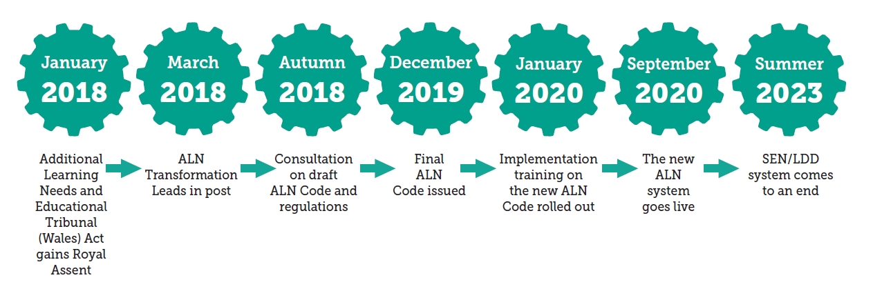
The Additional Learning Needs and Education Tribunal (Wales) Act (ALNET) has been passed and will be supported by a new Code. This sets out how the ideas from the act will work in practice. The draft code was published in December 2018 and a consultation ran until 22nd of March 2019. The final Code will be published towards the end of 2019.
Key Messages:
- The term Additional Learning Needs (ALN) will replace the terms Special Educational Needs (SEN) and Learning Difficulties and Disabilities (LDD). Children with ALN will be supported through additional learning provision (ALP).
- SENCos will now be called an ALNCo (additional learning needs coordinator).
- The new code will cover children and young people aged 0 – 25 year olds, which means further education colleges and specialist independent colleges will now also be included (although not higher education or apprenticeships.)
- There will be an emphasis on high aspirations and improved outcomes for children and young people with ALN.
- The graduated system of school action, school action plus and statements is being replaced and all children who are identified as having ALN, under the new Code, will have an Individual Development Plan (IDP). The IDP will replace current Individual Education Plans (IEPs).
- Most IDPs will be maintained by the school but where it is considered unreasonable for the school to do so (such as for those with more severe or complex ALN) the Local Authority may maintain them.
- There will be an increased participation from children, young people, parents and carers in the creation and maintenance of IDPs through person centered planning.
- It is hoped that closer collaboration and working together in partnership should help us to avoid disagreements.
- All reasonable steps will be taken to secure provision in Welsh if required.
- All children and young people who have an IDP will have an equal right to appeal to tribunal.

If you wish to read the draft code there is both a full version and an easy read version available by following this link: https://beta.gov.wales/draft-additional-learning-needs-code
If you would like any additional information or advice please contact your school SENCo/ALNCo or you can contact SNAP Cymru who offer free, independent advice and support to parents by visiting: www.snapcymru.org or calling their helpline on: 0808 801 0608
Yours Sincerely,

Mr Huw Rowlands,
Head Teacher.



