
Craft Club
Beginning on Tuesday 24th February
Mrs Barber & Mrs Wilkinson will be holding
a Craft Club for all pupils until 4pm, this will continue every Tuesday until Easter.
Please can you email ysgol.dyffryn.ial@denbighshire.gov.uk to confirm your child’s attendance and commitment for the 5 weeks.
There will be no performing arts club on a Monday after half term, but this will begin again after Easter.

“Ga i fynd i ……… cei, wrth gwrs”
Dates for your Diary
- 13th February – Pyjama day and bring a teddy
- 26th February – Xplore trip - Dosbarth Tysilio
- 3rd March – St David’s Day Eisteddfod at 2pm
- 4th March – Dangerpoint Trip – Whole School
- 5th March – World book day
- 9th March – Parents Evening Years 5 & 6
- 11th March – Parents Evening Dosbarth Tysilio & Years 3 & 4
- 18th March – Parents Evening Dosbarth Tysilio
- 18th March – ‘Come dine with me’ – Dosbarth Tysilio
- 24th March – ‘Come dine with me’ – Dosbarth Tecla
- 25th March - Easter Service – at St Tysilio’s Church Bryn Eglwys at 10am

Safeguarding
If you have any safeguarding concerns, please contact one of our designated safeguarding leaders Mr Shaun Valentine, Mrs Ruth Barber or Mrs Sian Wilkinson on 01978 790645.

Winning Team
GLYNDWR
After School Club
A private After School Club is available in the Memorial Hall Julie Tudor 07984613534

Dosbarth Tecla
- We started the week with a bang as Johnny from Denbighshire Music Services came to see us and teach us some familiar songs on the Glockenspiel. He was very impressed with the class and commented on their great listening and concentration.
- We are continuing to enjoy reading James and the Giant Peach. We’ve been busy completing punctuation tasks based on extracts from the story as well as using apostrophes to shorten words. As a class we’ve also looked at different connectives used within the text.
- In PE this week we have been learning the dance “Ffansi Ffarmwr” in preparation for our School Eisteddfod.
- In maths Bl3 worked on their 2,4 & 8 times tables, Bl4 were dividing a 2 digit number by a 1 digit number, Bl5 were dividing a 4 digit number by a 1 digit number and Bl6 were solving ratio problems.
Other News – Newyddion Arall
Dosbarth Tysilio
- We have created our own alien descriptions using adjectives and adverbs
- We have been representing the numbers 6,7 & 8 (Reception) and comparing numbers (Year 1 & 2) in our mathematical work
- We have been using our creative and literacy skills to explore the moon in our topic work
- In Cymraeg we have been learning weather patterns e.g. Sut mae’r tywydd? Mae hi’n bwrw eira
- We’ve also been learning a folk dance (dawnsio gwerin) in our indoor PE

HUMILITY
Well-being Wednesday
Thank you to Bl6 for leading WBW this term
- Olly – Puzzles
- William – Calennig (Welsh tradition for New Year)
- Myfi – Yoga
- Noah – Counting in French

Attendance
School Target: 95%
Whole School Year to Date: 94.3%
Last Week: Dosbarth Tecla 94%
Dosbarth Tysilio 99%

Want to see more? Remember to connect to Seesaw
Website www.ysgoldyffrynial.co.uk for regular updates

School Newsletter
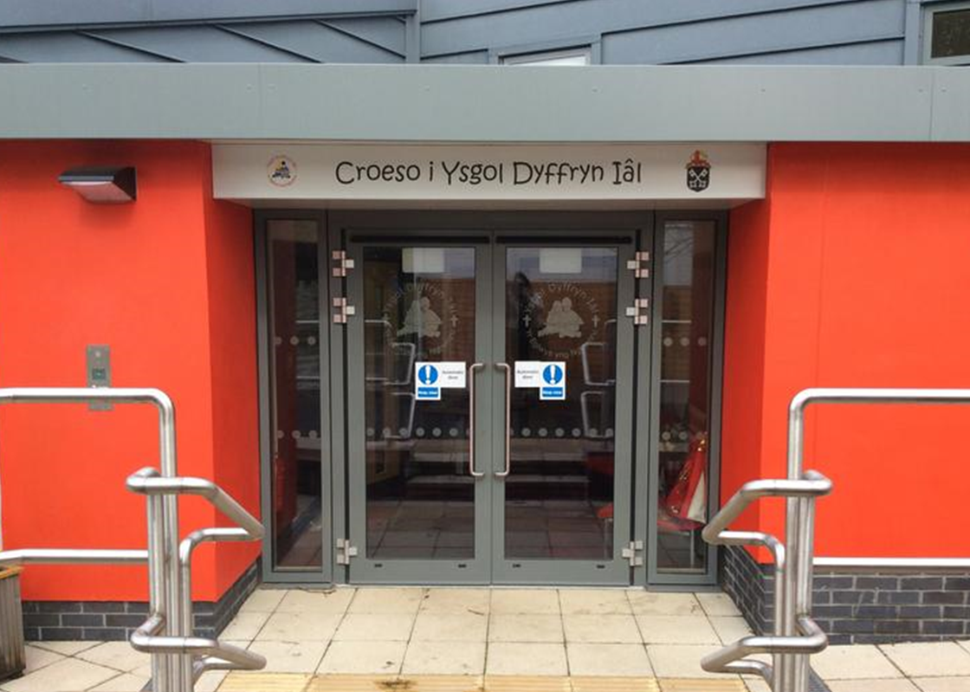


Christian Focus For This Half Term


Welsh Phrase of the Week
Class News – Newyddion Dosbarth
6ed Chewfror 2026
Ysgol Dyffryn Iâl



