“Ble mae Llandegla? Mae Llandegla yn Gogledd Ddwyrain Cymru.”
Dosbarth Tysilio
- This week, we have explored the use the use of ‘bossy’ verbs for commands and enjoyed the story ‘Tidy’ by Emily Gravett. We’ve also used our prediction skills to write our own ending for the story.
- In Maths, Year 1 and Year 2 pupils have been practising how to add two two-digit numbers using partitioning and counting on skills. Meanwhile, Reception children have been focusing on finding bonds for 10 in two parts.
- As part of our topic work, we have been planting sunflower seeds and using our literacy skills to write instructions on how to plant a seed.
- During independent learning time, we have been using our weather data to create a graph of our findings and developing our creative skills by sketching a range of amphibians.

Dosbarth Tecla
- This week, we thoroughly enjoyed listening to the Canadian folk tale How the Stars Came to Be. The children then retold the story in their own words, and it was wonderful to see so many of them using words from this week’s spelling list in their writing. We were also very impressed with their fantastic attempts at using direct speech.
- We have been busy creating Top Trumps cards all about famous Canadian landmarks. The children had great fun designing their cards and enjoyed the opportunity to play the game with their friends too.
- In Cymraeg, we continued to practise our Welsh through games and activities. We also added more slides to our Welsh PowerPoint presentation all about Canada.
- In Maths this week Bl 3 have been measuring mass in grams & kilograms, while Bl 4 have been dividing by 10, Bl 5 have been drawing and interpreting line graphs, while Bl 6 have been working on the area of triangles.

IMPORTANT – Change for PE Next Week
There will be a change to PE lessons next week Dosbarth Tysilio’s PE lesson will be on Wednesday and Dosbarth Tecla’s PE lessons will be on Wednesday and Friday.

Urdd – Arts & Crafts

We invite the children who were placed in the top 3 to attend the awards evening on Monday 11th May in Denbigh Town Hall at 6pm. A huge well done to all our pupils.
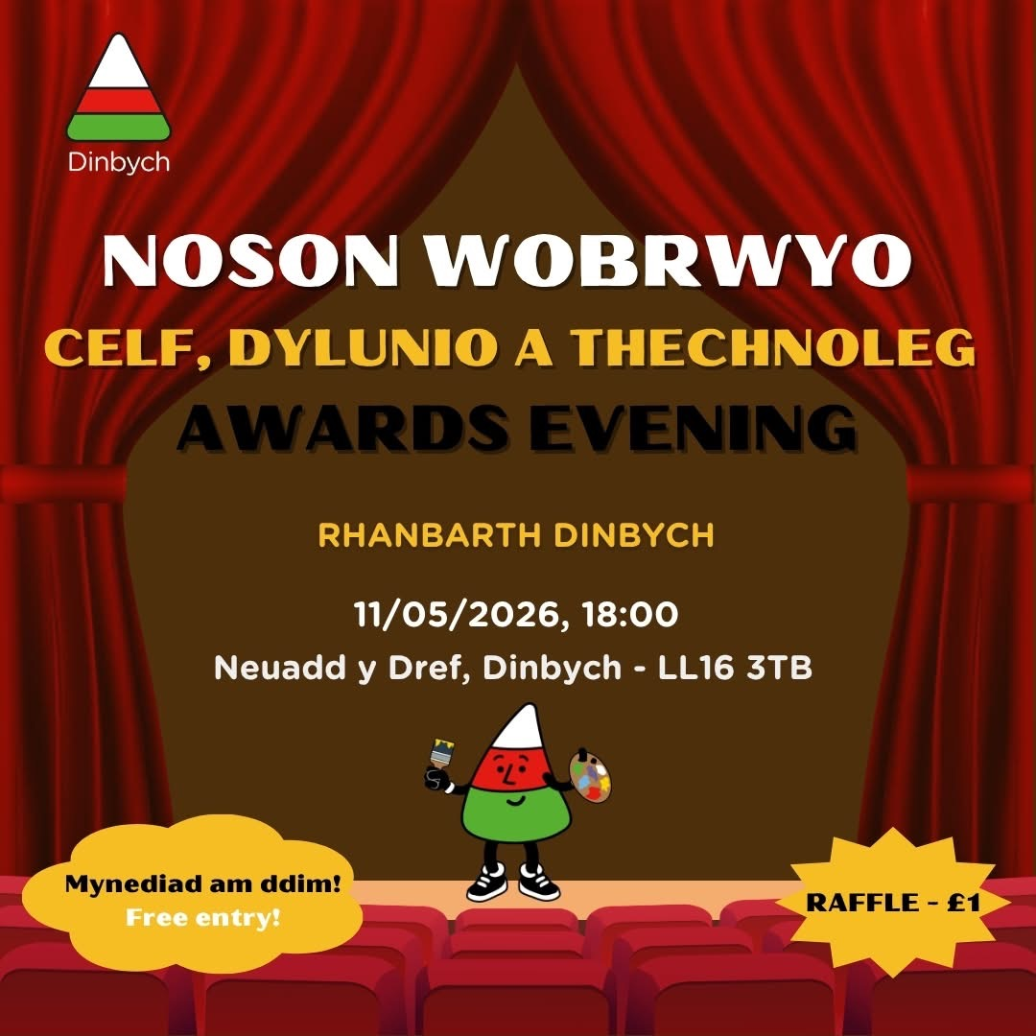
Dates for your Diary
- 11th May – Arts & Crafts Awards Evening – Denbigh Town Hall at 6pm
- 13th May – Whole School Photograph
- 22nd May – Break up for half term
- 23rd May – Urdd Eisteddfod in Anglesey
- 1st June – Back to school
- 10th June – Sports Day 1.30pm
- 12th June – School closed - Staff training day
- 17th – 19th June – Years 5 & 6 in Cardiff
- 23rd June – Transition Day – Ysgol Dyffryn Ial
- 3rd July – Year 6 Induction Day at Ysgol Brynhyfryd

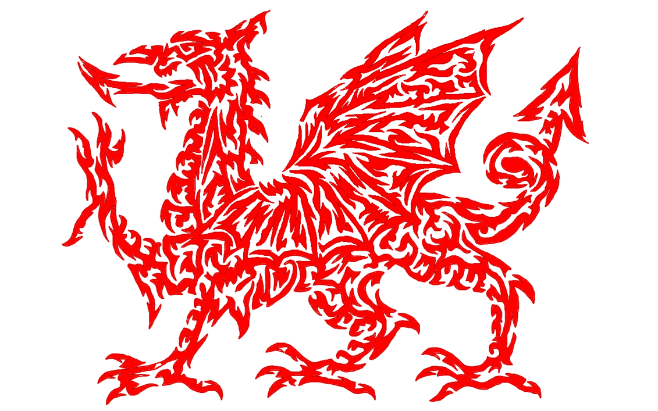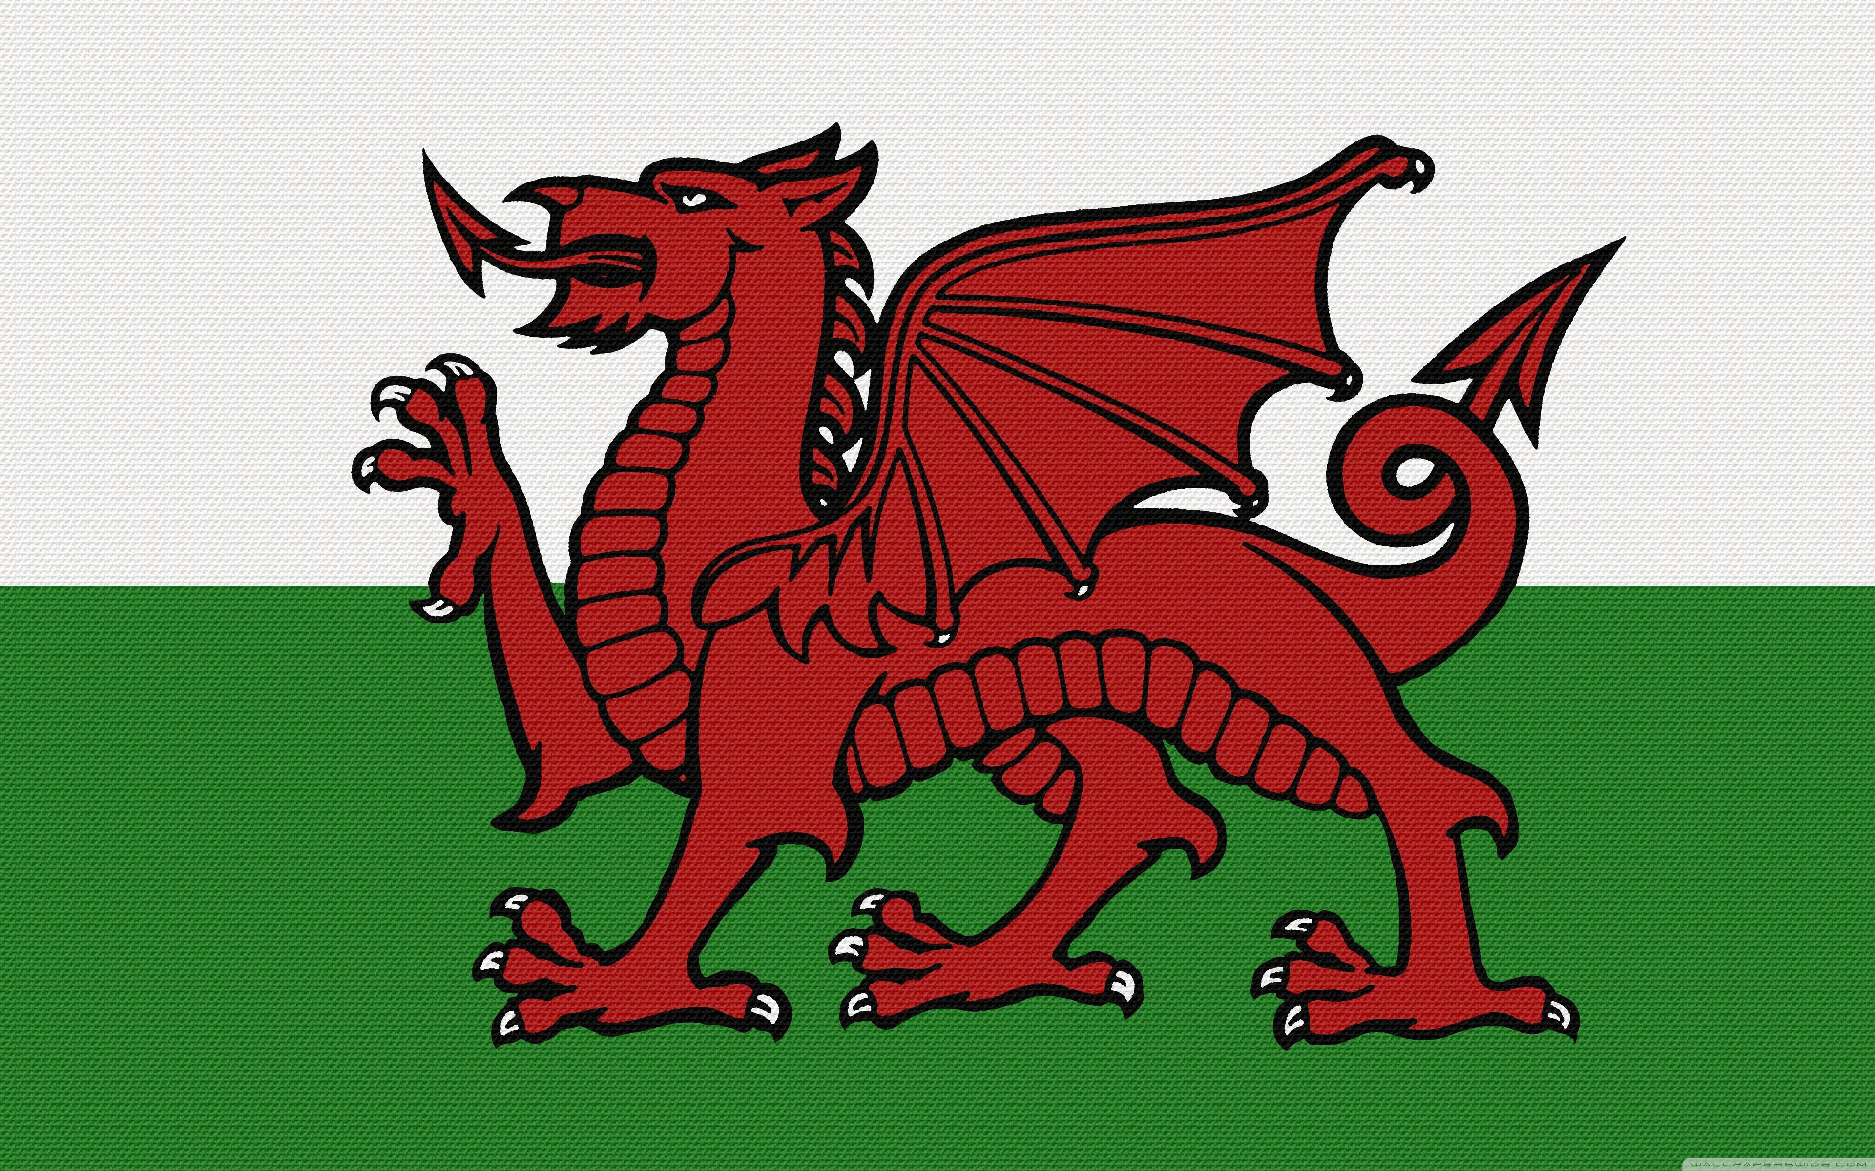
Other News – Newyddion Arall
Christian Focus For This Half Term

Class News – Newyddion Dosbarth
Want to see more? Remember to connect to Seesaw
Website www.ysgoldyffrynial.co.uk for regular updates
After School Club
A private After School Club is available in the Memorial Hall Julie Tudor 07984613534

Attendance
School Target: 95%
Whole School Year to Date: 94.3%
Last Week: Dosbarth Tecla 92%
Dosbarth Tysilio 87%

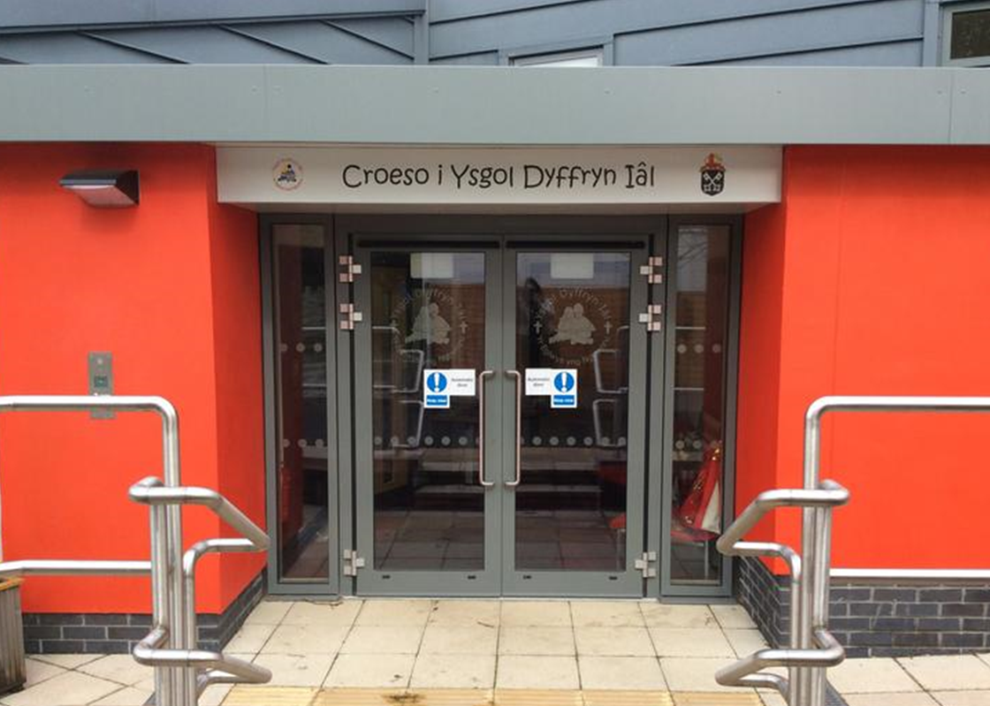
CREATIVITY
School Newsletter

Safeguarding
If you have any safeguarding concerns, please contact one of our designated safeguarding leaders Mr Shaun Valentine, Mrs Ruth Barber or Mrs Sian Wilkinson on 01978 790645.

Welsh Phrase of the Week
8fed Mai 2026
Winning Team
IAL

Ysgol Dyffryn Iâl



