Urdd – Arts & Crafts

We invite the children who were placed in the top 3 to attend the awards evening on Monday 11th May in Denbigh Town Hall at 6pm. A huge well done to all our pupils.
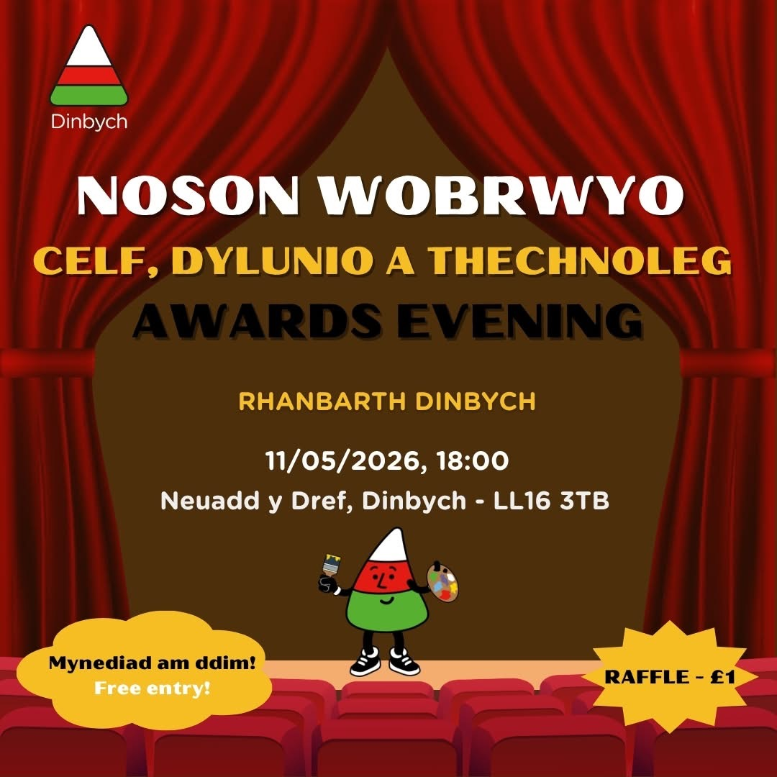

Dates for your Diary
- 11th May – Arts & Crafts Awards Evening – Denbigh Town Hall at 6pm
- 13th May – Whole School Photograph
- 22nd May – Break up for half term
- 23rd May – Urdd Eisteddfod in Anglesey
- 1st June – Back to school
- 10th June – Sports Day 1.30pm
- 12th June – School closed - Staff training day
- 17th – 19th June – Years 5 & 6 in Cardiff
- 23rd June – Transition Day – Ysgol Dyffryn Ial
- 3rd July – Year 6 Induction Day at Ysgol Brynhyfryd

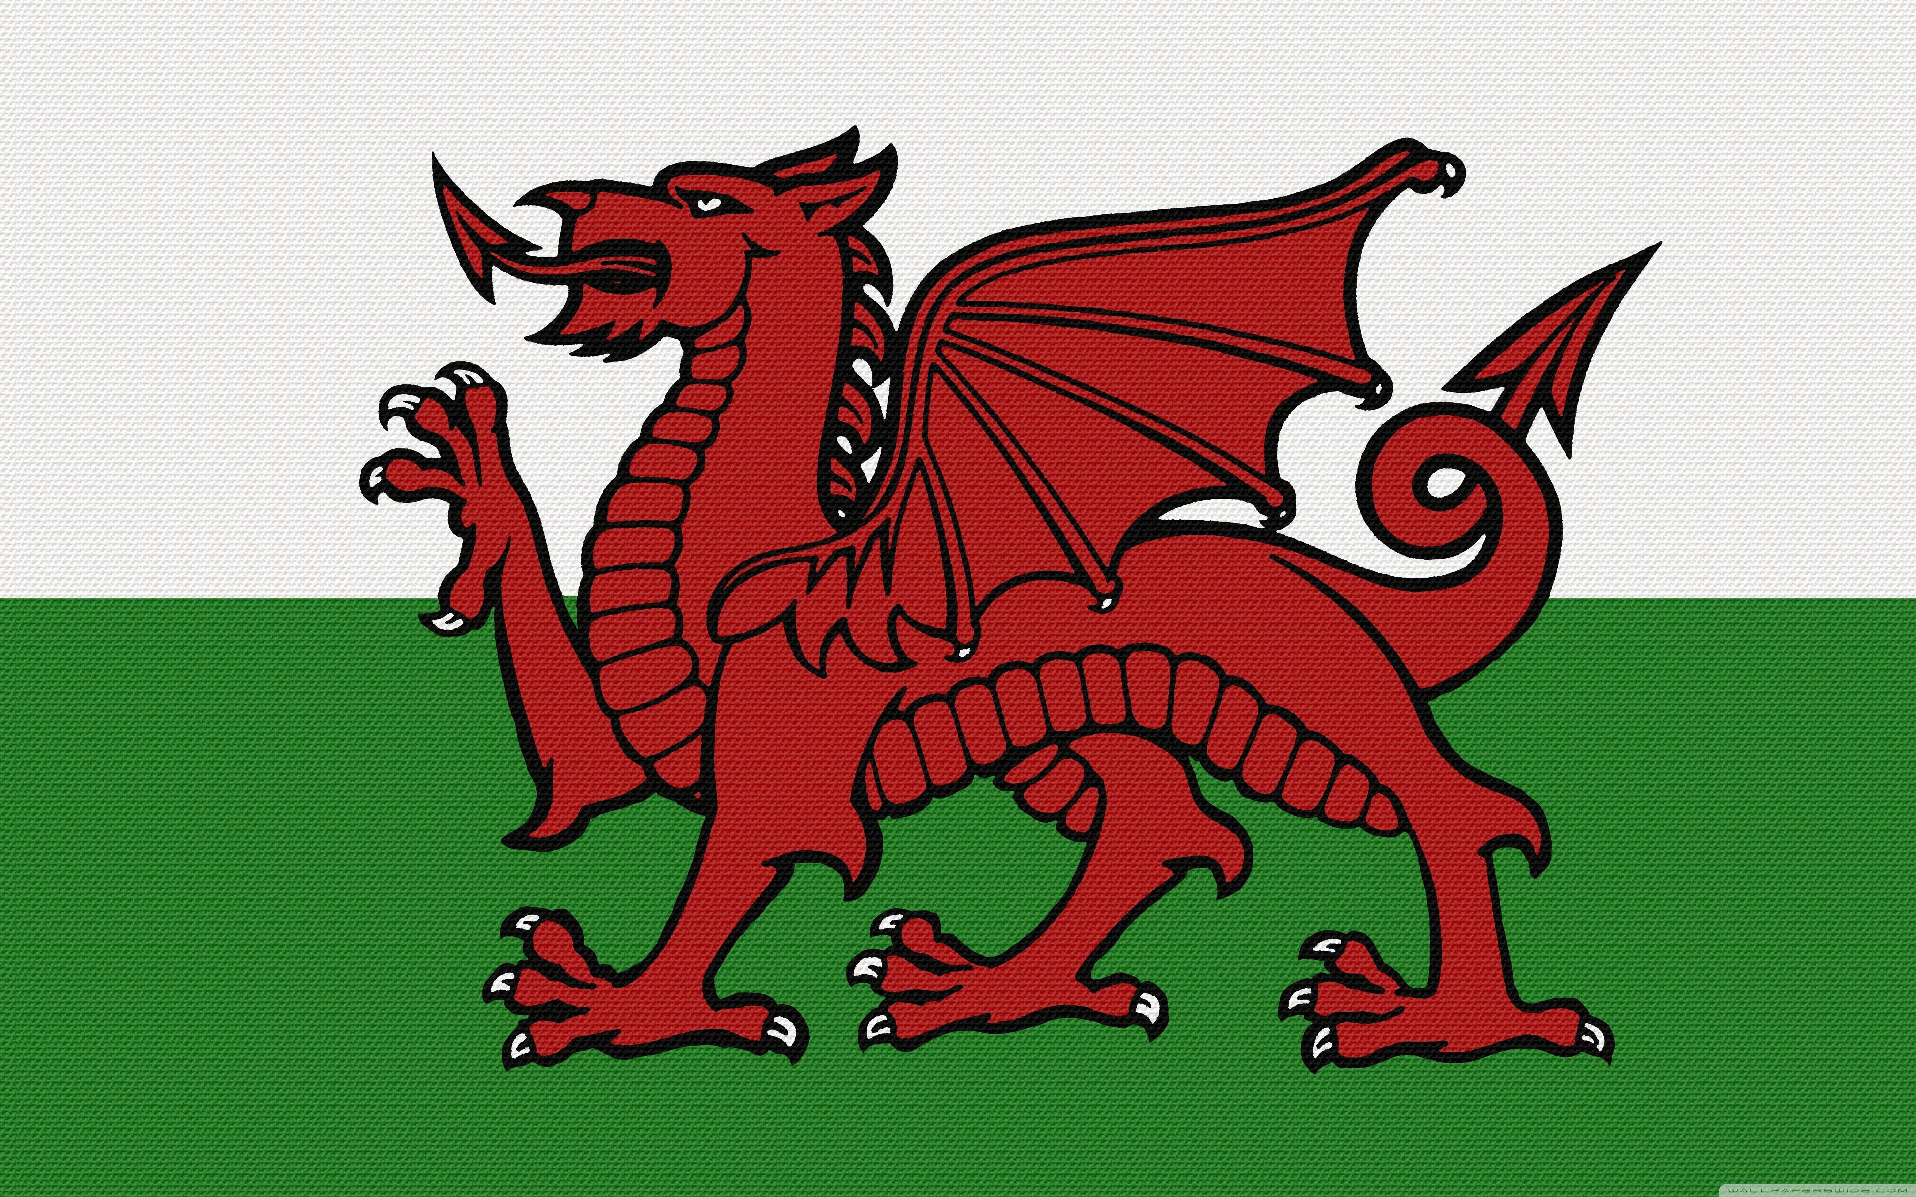
Dosbarth Tysilio
- This week, we have been busy editing our spring poems and creating our neat final copies. Reception children have also been learning the new digraph ‘oa’ and practising their letter formation outdoors.
- In Maths, Year 1 and Year 2 pupils have been practising how to add two two-digit numbers using partitioning. Meanwhile, Reception children have been focusing on finding one less and partitioning numbers up to 10.
- As part of our topic work, we have been using our literacy skills to design posters advertising the shop’s 10th birthday party, as well as creating birthday cards.
- During independent learning time, we have been developing our problem-solving skills through a range of activities, including completing spring-themed jigsaws, sketching pictures of the shop, mapping routes from the school to the shop, and recording the weather and temperature.

Dosbarth Tecla
- This week we have been busy developing our data-handling and scientific skills through a range of engaging activities.
- Pupils created their own graphs to represent the populations of the five most populated cities in Canada. They carefully followed checklists to ensure all key features were included, and many confidently presented their graphs in Cymraeg—da iawn!
- We continued to build our understanding of food chains (cadwyn fwyd) by designing our own examples featuring Canadian animals, which they accurately labelled.
- We also explored and interpreted climate data, answering questions about average monthly temperatures in both Caerdydd and Ottawa. Many pupils in Bl 5&6 successfully created detailed bar graphs that included both negative and positive temperatures—an excellent achievement.
- In Maths this week Bl 3 have been looking at fractions on a number lines, Bl 4 have been looking at tenths on a number lines, Bl 5 have been working on the area of compound shapes while Bl 6 have been calculating area.

Other News – Newyddion Arall
Christian Focus For This Half Term

Class News – Newyddion Dosbarth
“Faint o’r gloch ydy hi? Mae hi’n (10) o’r gloch.”
Want to see more? Remember to connect to Seesaw
Website www.ysgoldyffrynial.co.uk for regular updates
After School Club
A private After School Club is available in the Memorial Hall Julie Tudor 07984613534

Attendance
School Target: 95%
Whole School Year to Date: 94.4%
Last Week: Dosbarth Tecla 98%
Dosbarth Tysilio 93%

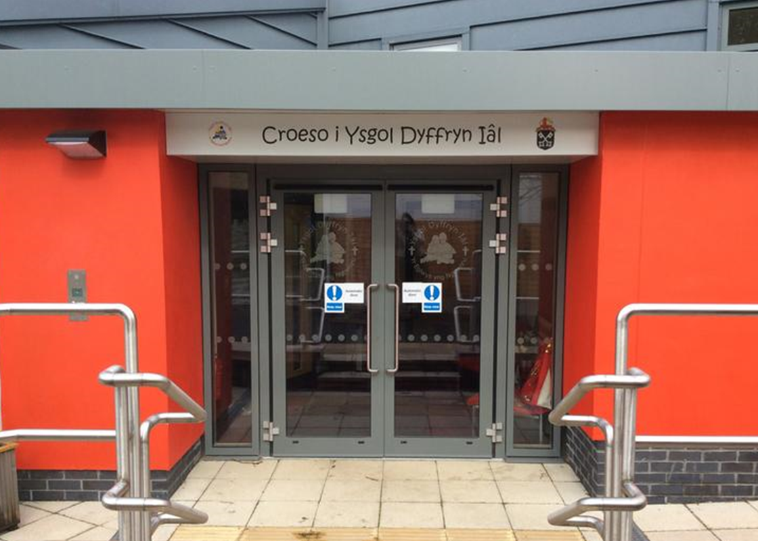
CREATIVITY
School Newsletter

Safeguarding
If you have any safeguarding concerns, please contact one of our designated safeguarding leaders Mr Shaun Valentine, Mrs Ruth Barber or Mrs Sian Wilkinson on 01978 790645.

Welsh Phrase of the Week
8fed Mai 2026
Winning Team
BERWYN

Ysgol Dyffryn Iâl



