Well- being Wednesday
To celebrate the Village shop turning 10;
Blwyddyn 6 pupils are leading in range
of well-being activities

- William- volunteering in the shop
- Olly - tidying up and planting flowers on the old school yard
- Myfi - making birthday cards
- Noah - sketching the Village shop and some of the volunteers
- We also have a group composing poetry and songs.


Attendance
School Target: 95%
Whole School Year to Date: 94.5%
Last Week: Dosbarth Tecla 99%
Dosbarth Tysilio 91%

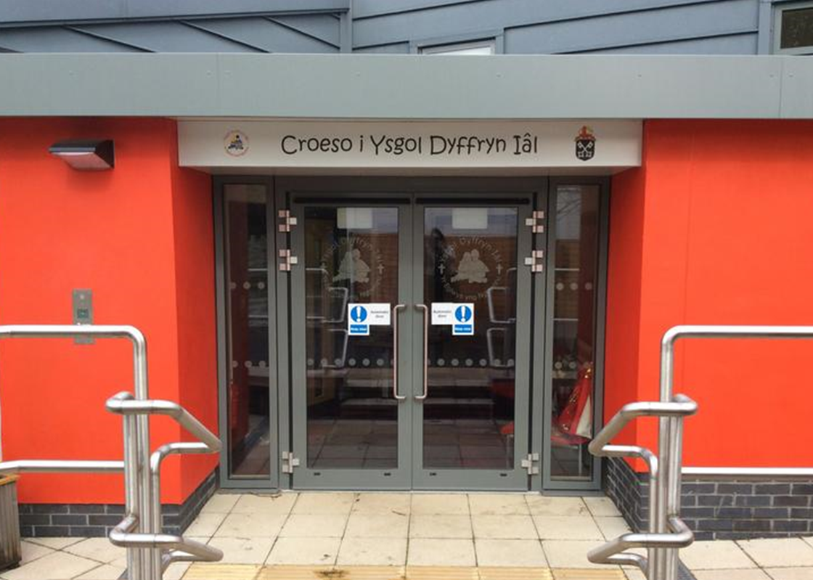

CREATIVITY
Class News – Newyddion Dosbarth
Dosbarth Tecla
- In Cymraeg we have been describing some of the animals that you may find in Canada. Mae'r arth frown yn enfwar. Mae ganddo bedwar coes. Mae o'n byw yn y goedwig..etc.
- We created our own branching game using J2data on Hwb. To create a successful branching game, we classified a range of Canadian animals by asking well-structured questions. Many pupils completed this task in Cymraeg, gwych!
- On Tuesday we had another great session with Kate. Pupils were enthusiastic and enjoyed playing all the various warm-up games as well as some rugby tag, Diolch yn fawr Kate.
- Don't forget to play spell blast to practise your spellings!
- In Maths Bl 3 have been comparing & ordering fractions, Bl 4 have been subtracting fractions, Bl 5 have been calculating perimeter, while Bl 6 have been finding percentages of amounts.

Dosbarth Tysilio
- This week, we have been busy exploring a range of poems inspired by spring, identifying familiar features and beginning to draft our own poems.
- In maths, Year 1 and Year 2 children have been practising adding two two-digit numbers using their knowledge of place value, while Reception children have been focusing on adding one more.
- As part of our topic work, we have been learning about amphibians, including what makes an animal an amphibian, and exploring the life cycle of a frog. We have also been carefully observing our tadpoles to spot any changes as they grow.
- During independent learning time, we have been creating our own spring information books, recording daily weather, and using tally charts to find out which season is the most popular.

School Newsletter

Safeguarding
If you have any safeguarding concerns, please contact one of our designated safeguarding leaders Mr Shaun Valentine, Mrs Ruth Barber or Mrs Sian Wilkinson on 01978 790645.

Christian Focus For This Half Term

Other News – Newyddion Arall
Welsh Phrase of the Week
“ Pa anifail wyt tin hoffi? ”


Dates for your Diary
- Tuesdays – Piano & Guitar lessons
- 28th April – PC Craig visiting Year 1- Year 6
- 4th May – School closed – Bank Holiday
- 13th May – Whole School Photograph
- 22nd May – Break up for half term
- 23rd May – Urdd Eisteddfod in Anglesey
- 1st June – Back to school
- 10th June – Sports Day 1.30pm
- 12th June – School closed - Staff training day
- 17th – 19th June – Years 5 & 6 in Cardiff
- 23rd June – Transition Day – Ysgol Dyffryn Ial

24ain Ebrill 2026
Winning Team
BERWYN
After School Club
A private After School Club is available in the Memorial Hall Julie Tudor 07984613534

Want to see more? Remember to connect to Seesaw
Website www.ysgoldyffrynial.co.uk for regular updates

Ysgol Dyffryn Iâl



