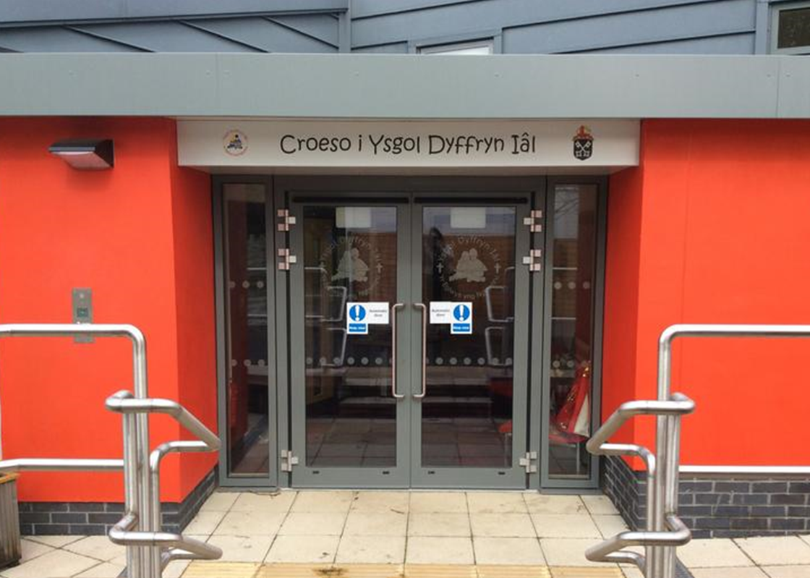
Well- being Wednesday
This term we are connecting with the Village Shop to celebrate 10 years!!
- Be Active – Weed, tidy and plant flowers in the old yard for the shops 10th birthday party
- Keep Learning – Compose and learn a song about the shop.
- Give – Create a card to give to the shop to celebrate their 10th birthday.
- Take Notice – Sketch the shop and create portraits of the volunteers

Attendance
School Target: 95%
Whole School Year to Date: 94.4%
Last Week: Dosbarth Tecla 99%
Dosbarth Tysilio 91%

ParentPay - Ordering Meals
An email has been sent out this week to remind parents to order their children’s meals for the week. Menus are available to view on ParentPay.

CREATIVITY
Class News – Newyddion Dosbarth
Dosbarth Tecla
- Our new topic this term is the World Cup Countries... and we begin with Canada!
- We have been incredibly busy this week locating Canada on a World Map as well as locating some cities, landmarks and distance from Cymru. In pairs we read about various cities and produced a poster sharing all the information that we read, including some fun facts! We have also used AI to create our new front covers for our topic books. In PE we warmed-up playing the game "Ball Champs" before developing our sending and receiving skills playing "4 Square". We will continue to develop our skills to be able to move quickly in different directions to reach the ball.
- We have also been busy working together to plan our missions and we look forward to completing these independently in the next few weeks. Da iawn chi!
- In Maths Bl 3 have been comparing and ordering unit fractions, Bl 4 have been adding and subtracting fractions, Bl 4 have been converting between decimals, fractions and percentages and Bl 6 have been dividing fractions.

Dosbarth Tysilio
- This week we have been busy finding out about the seasons. We enjoyed a signs of spring walk and made a record of all the things seen. Year 1 and 2 also used their digital skills to create a collage of their findings using the app PicCollage.
- In our mathematical work Reception have been busy comparing numbers, while Year 1 and 2 have been working on their place value skills by adding and subtracting 10’s to a given number.
- As part of our language work, we have been using adjectives and our senses to describe the spring season.
- We have also been busy sketching, creating models and building rockets using the loose parts based on the Artemis 2 space mission which launched over the Easter holidays.

School Newsletter

Safeguarding
If you have any safeguarding concerns, please contact one of our designated safeguarding leaders Mr Shaun Valentine, Mrs Ruth Barber or Mrs Sian Wilkinson on 01978 790645.

Christian Focus For This Half Term

Other News – Newyddion Arall
Welsh Phrase of the Week
“ Ga I helpu ”


Dates for your Diary
- Tuesdays – Piano & Guitar lessons

- 28th April – PC Craig visiting Year 1- Year 6

- 4th May – School Closed – Bank Holiday

- 13th May – Whole School Photograph

- 22nd May – Break up for half term

- 23rd May – Urdd Eisteddfod in Anglesey

24ain Ebrill 2026
Winning Team
IAL
After School Club
A private After School Club is available in the Memorial Hall Julie Tudor 07984613534

Want to see more? Remember to connect to Seesaw
Website www.ysgoldyffrynial.co.uk for regular updates

Ysgol Dyffryn Iâl



