Dosbarth Tecla
- This week, we have been busy preparing for our Easter service. In our groups, we were given the task of researching how different countries celebrate Holy Week. One group learned about how Australians celebrate Palm Sunday, while another group explored how Good Friday is celebrated in Bermuda. We worked collaboratively to write scripts, which we then read in St Tysilio Church.
- We also recreated the events of Holy Week in Minecraft. Some groups built the three crosses for the crucifixion of Jesus and the two other prisoners, while others created a busy Jerusalem scene showing people welcoming Jesus on his donkey on Palm Sunday.
- Finally, a big thank you to Fleur’s mum for bringing in some baursaks, a traditional snack eaten in Kazakhstan. They were delicious and a perfect way to end our class topic, “Food Glorious Food!”
- In maths Bl 3 have been measuring perimeter, Bl 4 have been converting mixed numbers and improper fractions, Bl 5 have been ordering and comparing decimal numbers and Bl 6 have been working on multiplying and dividing decimals by integers.

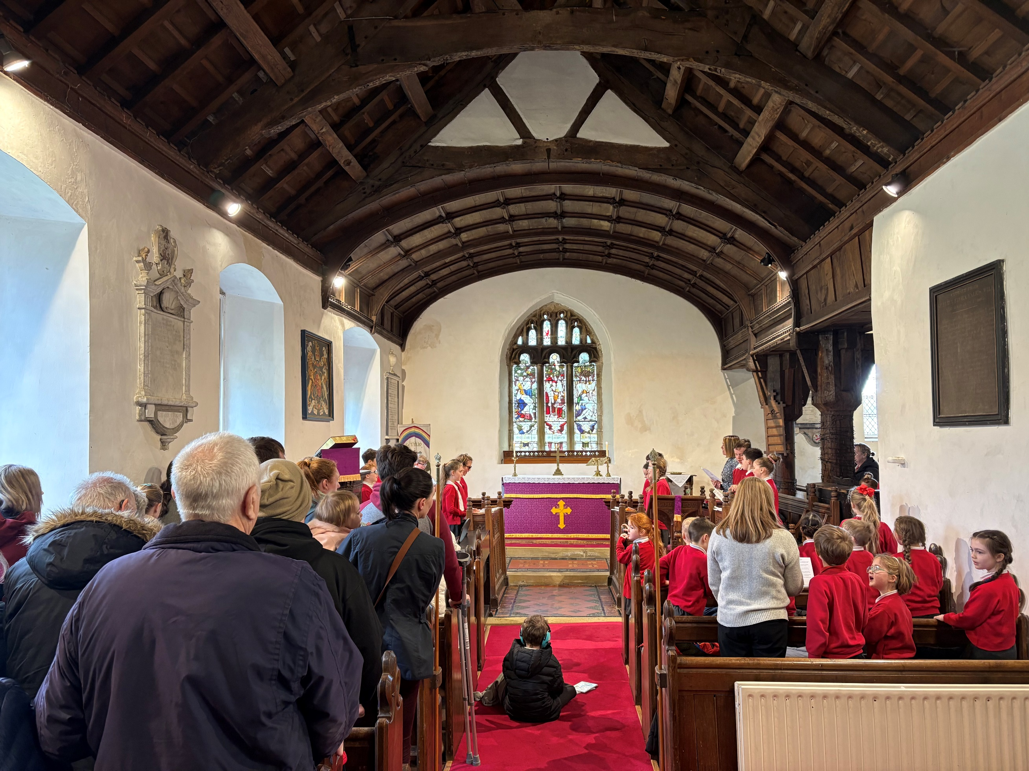
Come Dine With Me
Dosbarth Tecla

It was lovely to see so many parents and grandparents at our ‘Come Dine With Me’ event on Tuesday. The children thoroughly enjoyed having lunch with their family members.



Dates for your Diary
- 27th March – FOYDI Movie night 3.15pm-5pm
- 27th March – Break up for Easter
- 13th April – Back to School

Dosbarth Tysilio
- We have been creating Easter poems using alliteration
- We have been carrying out an investigation to explore lunar craters
- In our mathematical work Reception have been exploring the numbers 9 and 10, while Year 1 and 2 have been working on subtraction patterns
- We have also been making Easter cards in our creative work
- We have finished off the week with an Easter egg hunt around the field

Other News – Newyddion Arall
Welsh Phrase of the Week
Christian Focus For This Half Term

Class News – Newyddion Dosbarth
Urdd Eisteddfod Llangollen
Congratulations to our group of pupils who performed at Llangollen Pavilion at the weekend and have secured places at the Urdd Eisteddfod in Anglesey in May.
Easter Service
We were delighted to be back in Bryneglwys village this week. It was lovely to see so many of our parents and grandparents joining us. Thank you for your support.
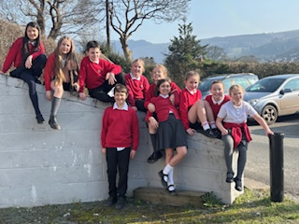

Attendance
School Target: 95%
Whole School Year to Date: 94.3%
Last Week: Dosbarth Tecla 93%
Dosbarth Tysilio 98%

27ain Mawrth 2026
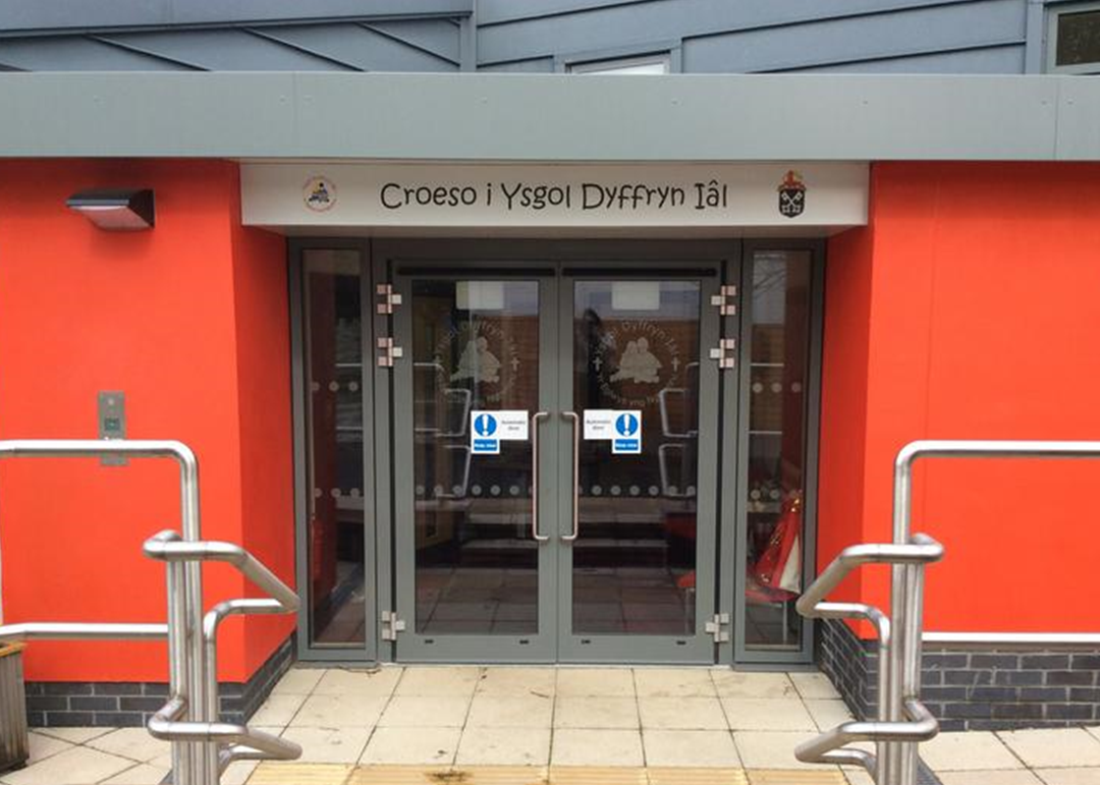
Winning Team
GLYNDWR
Safeguarding
If you have any safeguarding concerns, please contact one of our designated safeguarding leaders Mr Shaun Valentine, Mrs Ruth Barber or Mrs Sian Wilkinson on 01978 790645.

“Pasg Hapus i ti!”
After School Club
A private After School Club is available in the Memorial Hall Julie Tudor 07984613534

HOPE
Want to see more? Remember to connect to Seesaw
Website www.ysgoldyffrynial.co.uk for regular updates

School Newsletter

Ysgol Dyffryn Iâl



