Church In Wales School
Ysgol Eglwys Yng Nghymru


Prospectus Prosbectws
2026-27 2026-27

Ysgol Dyffryn Iâl

“We learn, we smile, we live, we dream together”

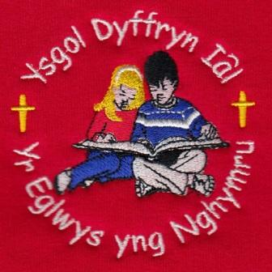

“Dysgu,Gwenu,Byw,Breddwydio – Gyda’n Gilydd”

Welcome to Ysgol Dyffryn Iâl
Croeso i Ysgol Dyffryn Iâl

Dear Parent/Carer,

We are delighted to extend a warm welcome to you and your child as you express an interest in joining Ysgol Dyffryn Iâl, a Church in Wales School. We pride ourselves in serving the communities of Llandegla, Bryneglwys, and other surrounding villages, and we are excited to have the opportunity to work with you and your child in their educational journey.

At Ysgol Dyffryn Iâl, we aim to provide a happy and friendly school environment where children feel safe, valued, and motivated to learn. We firmly believe in working collaboratively with parents, as we believe that a strong partnership between home and school is essential for a child's success and well-being.

Our dedicated team of teachers and staff are committed to delivering a high-quality education that meets the standards set out in the Curriculum for Wales. This curriculum is designed to provide a broad and balanced educational experience, nurturing the holistic development of every child.

As a Church in Wales School, we value the principles of faith and spirituality. We encourage respect, tolerance, and acceptance of all individuals. We believe in promoting a sense of community and supporting children in becoming caring and responsible citizens.

To help your child settle into our school, we offer a comprehensive induction process. This includes opportunities for both you and your child to meet the teachers, tour our facilities, and understand the school's policies and procedures.

We are committed to ensuring your child feels supported and welcomed from the very first day.

Should you have any questions or require further information, please do not hesitate to contact our school office on 01978 790645. We are more than happy to address any concerns and provide the necessary guidance.

Thank you for considering Ysgol Dyffryn Iâl as your child's educational home. We look forward to meeting you and working together to provide a positive and enriching educational experience for your child.

Yours faithfully,

Shaun Valentine
Headteacher
Ysgol Dyffryn Iâl.
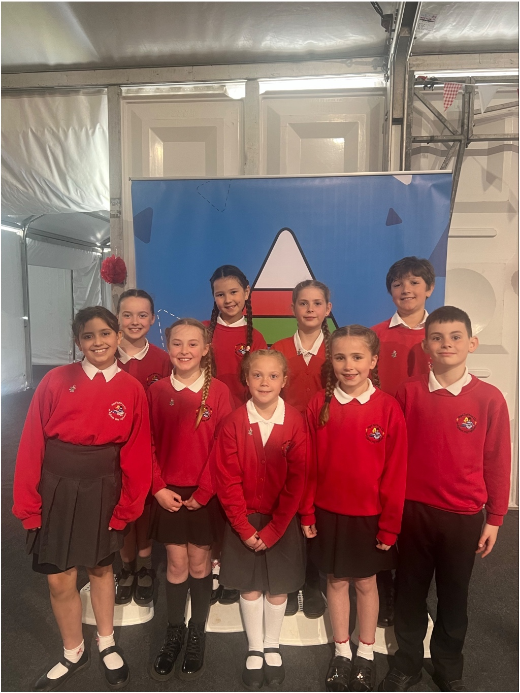

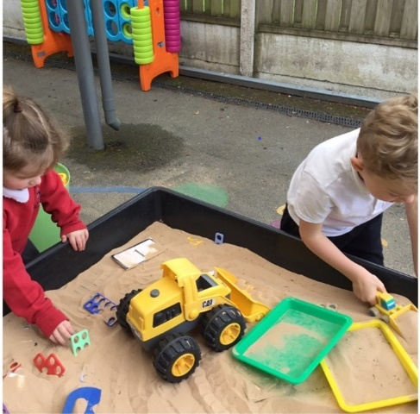

Staff List

Headteacher: | Mr Shaun Valentine
Teacher – Dosbarth Tysilio (3-7-year old classroom): | Mrs Ruth Barber  Mrs Alys Williams (Mondays)
Teacher- Dosbarth Tecla (7-11-year old classroom): | Mrs Sian Wilkinson
Teaching Assistant – Dosbarth Tysilio (3-7-year old classroom): | Ms Fiona Royles
Teaching Assistant- Dosbarth Tecla (7-11-year old classroom): | Mrs Sandra Hampson
Additional Learning Needs Coordinator: | Mrs Ruth Barber
School Secretary: | Mrs Sian Griffiths
School Caretaker: | Mrs Sandra Hampson
School Cook: | Mrs Joy Thompson
Breakfast Club: | Ms Sandra Williams-Blythen  Ms Julie Tudor  Mrs Gaynor Wonderley

School Background

Ysgol Dyffryn Iâl is a school that takes great pride in providing exceptional education to children aged between 3 and 11 years old.

Situated in the picturesque village of Llandegla, Ysgol Dyffryn Iâl not only serves the local community but also reaches out to Bryneglwys and surrounding villages. We are a Church in Wales voluntary controlled school, under the stewardship of the Diocese of St Asaph, and are blessed to foster a truly inclusive and caring environment.

At Ysgol Dyffryn Iâl we teach predominantly through the medium of English but with significant use of the Welsh language. The home language of all pupils is English.

At Ysgol Dyffryn Iâl, we are driven by our commitment to create a happy and friendly school that nurtures the development and growth of each and every child who walks through our doors. Through our high expectations and unwavering belief in the potential of our pupils, we aim to foster a love for learning and facilitate a lifelong passion for knowledge.

To ensure the best possible learning outcomes, our school is divided into two classes: Dosbarth Tysilio for children aged 3 to 7 years old and Dosbarth Tecla for those aged 7 to 11 years old. Each class is led by dedicated and experienced teachers who hold a deep understanding of the 2022 Curriculum for Wales and strive to deliver innovative and engaging lessons.



The warmth and strength of the working relationships between pupils and staff mean that the pupils feel safe in the school and know what to do if they feel worried or anxious...
...Teachers and learning support assistants work very effectively as a team and take advantage of every opportunity to enrich pupils’ learning ...
Estyn 2019

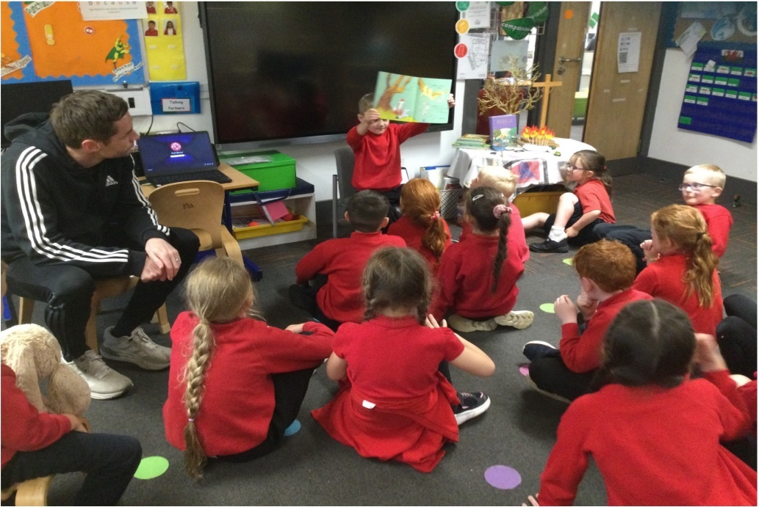

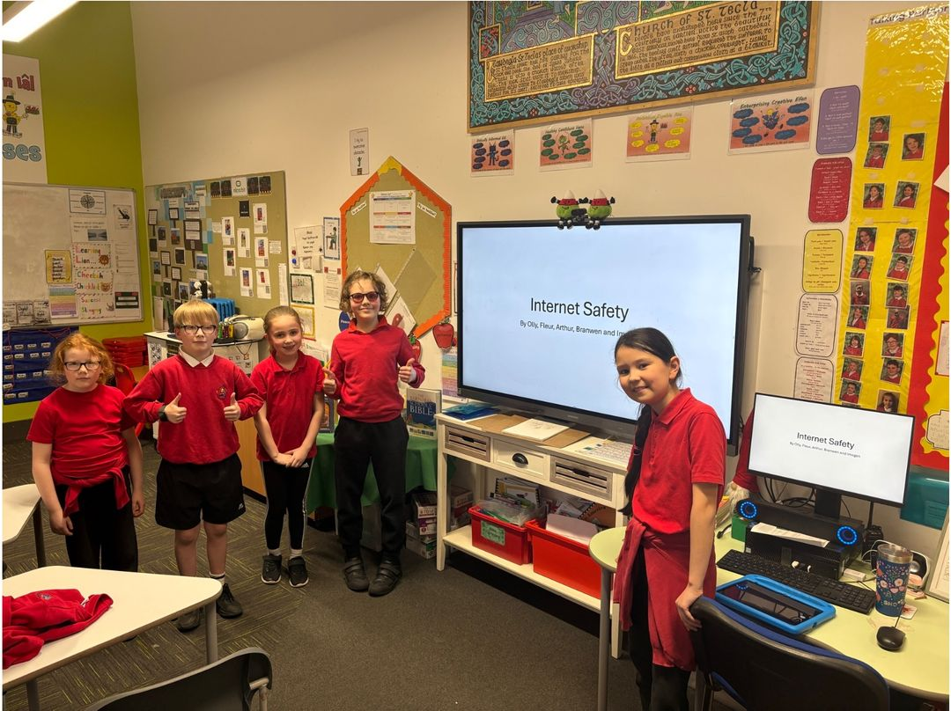

Mission Statement

We Learn, we Smile, we dream,

we live together.

Our Aim


At Ysgol Dyffryn Iâl we aim to provide an outstanding learning environment that is happy, supportive and where children’s confidence and curiosity as life-long learners is nurtured to reach their full potential in an inclusive Christian ethos.

One of the school’s strong features is the very kind and supportive way in which the older pupils care for the younger pupils. The support of playground buddies, lunch time buddies and reading buddies contributes well to the school’s inclusive and caring ethos…

Estyn 2019

Ethos
Our school's ethos is centred on the happiness and well-being of our children, providing them with a safe and comfortable environment where they can feel happy, secure, and fulfil their potential. Our aim is to offer the best possible education, tailored to each child's individual needs. We firmly believe that this approach sets our school apart and ensures that our children receive an outstanding educational experience.

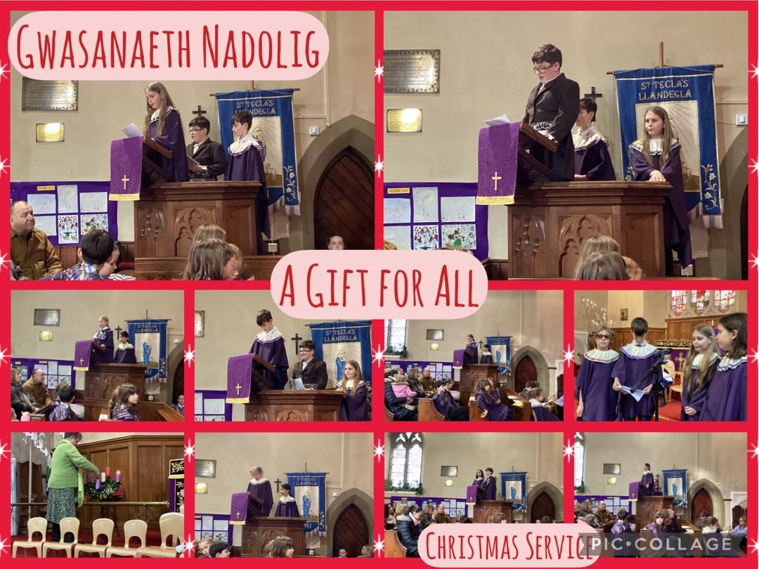

A SCHOOL LED BY CHRISTIAN VALUES

Ysgol Dyffryn Iâl aims to serve its community by providing education of the highest quality within the context of a Christian belief and practice. We encourage an understanding of the meaning and significance of faith and promote Christian values through the experiences we offer to develop the whole child.

As a Church in Wales school, our vision and ethos is based on a spiritual and moral foundation. Our school is a special place, a safe place, a place of learning, a place of nurture and of exploration. Our school must demonstrate openness and acceptance, tolerance and forgiveness. Here, values and attitudes are formed and every individual is celebrated as being unique.

The school community has adopted a common set of core Christian values which underpin the curriculum, school policies and the work of the governing body. They are the basis for the social, intellectual, emotional, spiritual and moral development of each child. We encourage pupils to consider these values, thereby developing knowledge, skills and attitudes that enable them to develop as reflective learners and grow to be compassionate, educated and fulfilled members of society.

Each half-term we focus on one value from the following list:

Happiness, Generosity, Thankfulness, Hope, Truth, Friendship, Trust, Perseverance, Responsibility, Courage, Forgiveness, Compassion.

Our three main Christian Values chosen by the pupils are: Wisdom, Friendship and Respect.

Staff establish a positive working relationship with pupils, which fosters successful learning.
Estyn 2019
Our Curriculum

The Curriculum for Wales became statutory in September 2022. The purpose of this curriculum it enable learners to develop the four purposes.

- Ambitious, capable learners, ready to learn throughout their lives.

- Enterprising, creative contributors, ready to play a full part in life and work.

- Ethical, informed citizens of Wales and the world.
- Healthy, confident individuals, ready to lead fulfilling lives as valued members of society.

The curriculum is taught through 6 areas of learning and experience:
- Expressive Arts
- Health and Wellbeing
- Humanities
- Languages, Literacy and Communication
- Mathematics and Numeracy
- Science and Technology

A curriculum is important to every school and its learners. When designing Ysgol Dyffryn Iâl’s curriculum we have ensured that the learning will be engaging, relevant, challenging and motivational to children in the classroom and beyond.

Our aim is to provide high quality teaching experiences will ensure our learners are ambitious, enterprising, ethical and healthy citizens.

Our appealing and engaging topics, together with pupil voice, will allow learners to have opportunities to work in ways that enhance their learning and also present their work in their own unique and personal way.

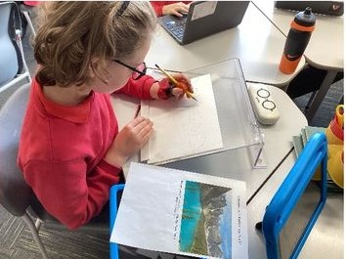

Assessment and Reporting to Parents

The staff continuously assesses the progress of each child throughout the school year using a variety of methods, including Assessment for Learning, Marking and Feedback, Observations and personalised assessments.

On entry to the Nursery and Reception Class children will be assessed using a Base-line Assessment. National Numeracy and Literacy tests are taken twice a year from pupils in Y2-6.

The school uses Assessment for Learning principles and our pupils are encouraged to assess their own progress and learning, especially the older children, who are involved in setting their own targets.

A detailed report on each pupil’s progress will be sent home annually in July.
Consultative Parents Evenings provide opportunity for parents to see their child’s work and discuss progress with teachers. These are held in the Autumn and Spring Terms.

Policies

If you wish to view any of our policies, please do ask at the school office. Key policies are available on the school website.

Ysgol Dyffryn Iâl 9

Admissions
For the academic year, 2026-2027 administration of the
admission arrangements for Ysgol Dyffryn Iâl is the responsibility of
the Local Authority. A booklet setting out the admissions procedures and
criteria for each school in the county together with an application form is
available from Denbighshire County Council Website. Forms must be
returned to the Admissions Department by the closing date each
year for applications for places.

In accordance with the Local Authority children are admitted to school:
- Five afternoons starting from the term following their 3rd birthday (Rising 3’s)
- Five afternoons in September following their 3rd birthday (Nursery).
- Full Time in September following their 4th birthday.
Appeals
Every effort is made to make a place available for your child in our
school. However, schools have a limit on the number of children they can
take. This figure is set by the Local Authority and agreed with the
School Governors and Headteacher. If the number of children wanting a
place is below the set figure, all will be admitted. There may, however,
come a point when there are too many children of that year group for them
all to be given a place.

If a place is not available on application you have the right to put your case
to an Admissions Appeal Panel. An independent panel will hear your case.
It has the power to admit pupils to year groups exceeding the set number of places.

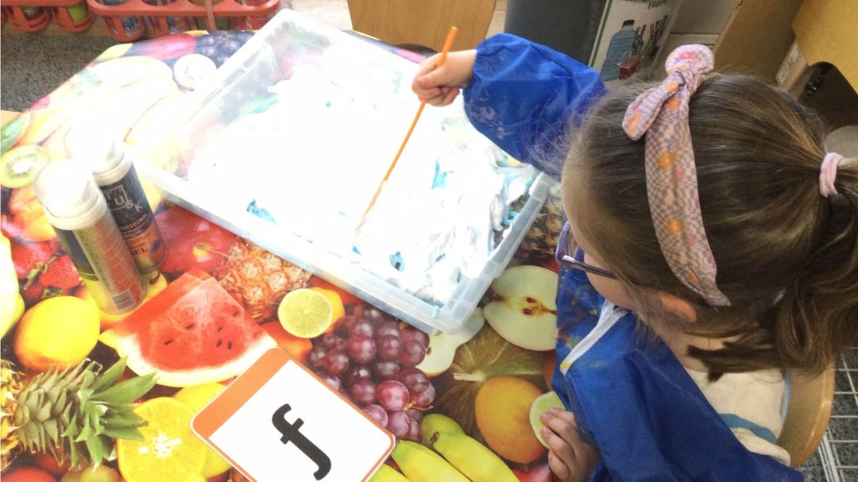
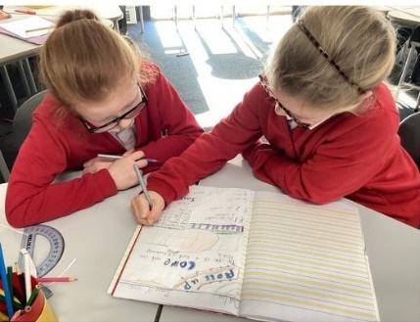

Additional Learning Needs
The school adheres to Denbighshire County policies and the national guidelines laid down in the Additional Learning Needs Code of Practice.

Mrs Ruth Barber is the ALNCo (Additional Learning Needs coordinator) at Ysgol Dyffryn Iâl. As part of our regular monitoring systems, i.e. pupil tracking systems, we can identify children's strengths and weaknesses and ensure that they make the best progress. Where necessary, children are given extra support according to their individual requirements. These additional needs may require support for long or short periods of time. Where extra support is necessary, parents are included in a dialogue with the class teacher on how to support the child moving forward.

The ALNCo, alongside the class teacher will develop intervention strategies which are monitored through our robust tracking system. The school's support staff work with individuals and small groups of children on specific skills.

When there is continued concern about a child’s progress, additional advice and/or assessment may be requested from external agencies.
The school aspires to be fully inclusive. All reasonable adjustments are made to the environment and teaching and learning activities to ensure that children with disabilities are not disadvantaged.

More Able and Talented

In the case of more able and talented children, class work is carefully planned to extend and challenge them in order for them to reach their needs.

Equal Opportunities

At Ysgol Dyffryn Iâl, we are committed to ensuring equity of education and opportunity for all pupils, staff and parents and carers receiving services from the school, irrespective of disability, race, gender, age, sexual orientation, religion or belief.

We aim to develop a culture of inclusion and diversity in which all those connected to the school feel proud of their identity and able to participate fully in school life.

At Ysgol Dyffryn Iâl we strive for “empowerment” by reducing the barriers for our learners
Access and Admission for Disabled Pupils

The school is one-level and its layout is accessible to all the pupils and visitors. There is also a large disabled toilet on-site. Local Authority policies and procedures ensure pupils with disabilities are not discriminated against and have equal access to the school curriculum and facilities.

Medicines and Medical

Teachers may administer medication if the parents/guardians have signed the relevant form.

At various stages through your child’s stay in school, they will be seen by the School Nurse. Parents will be informed of these visits and will be able to refuse the review.

If your child needs to take any medicine prescribed by the doctor, please try to give the medicine out of school hours. If this is not possible please see Mrs O’Callaghan. You will need to complete an Administration of Medicines form with full details of medication, dosage and times to be administered. This information must comply with the information on the original medication bottle. Medication is then to be handed in at the school office along with the consent form. Under no circumstances should children bring medication into school in their bag.

If your child has to be excused from PE lessons on medical grounds please inform the class teacher or contact the office. Children suffering from asthma should carry their asthma pumps at all times and be able to use them properly.
No medication will be given to a child without the form.
Health and Safety / Emergencies
Occasionally, accidents do happen in school and although there is always a teacher available with training in first aid and in the event of minor accidents, parents/carers are informed of the details. If there is an accident of a more serious nature then parents will be asked to come to school.
In the case of an emergency, the school will take immediate action to safeguard any child before contacting parents, i.e. call an ambulance.
Risk assessments are always carried out for out of school activities.
Please ensure all emergency contact numbers (mobile and landline) are kept up to date on the school system by contacting the office via phone email.

Communication with Parents and Home-School Agreement

We are very committed to ensuring that parents are kept fully informed of school events, key issues and your child’s progress. This takes place in the following ways:

- Weekly Newsletters
- Seesaw
- School Website
- E-Mails
- Parents’ evenings
- Open door policy and class teachers make themselves available whenever possible at the beginning and end of the school day.

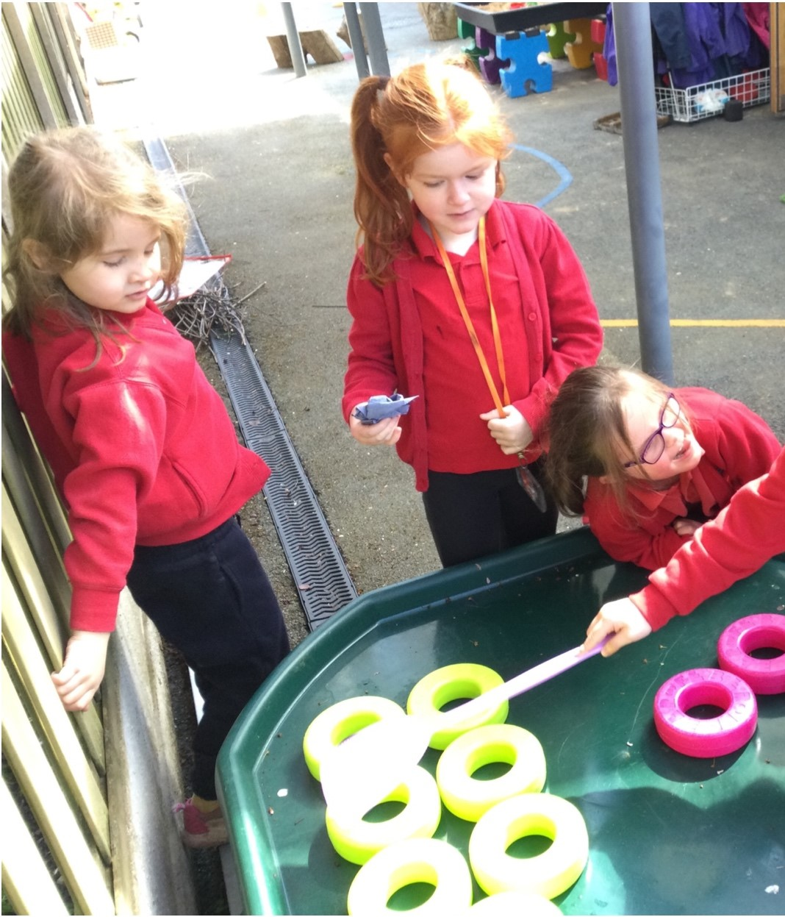

A school cannot succeed without the support of parents. We therefore urge you to take an interest in your children’s education and to support the school in its daily and public activities. We ask parents/carers and children, along with the Headteacher to sign a Home-School Agreement which notes the responsibilities and duties of the school, parents and child to ensure the best possible education and every opportunity to succeed for each child. A copy will be given to you.

The School Day
Dosbarth Tysilio (3-7-year olds)  Dosbarth Tecla (7-11-year olds) | Morning Session  9.00 am – 12 noon
Dosbarth Tysilio (3-7-year olds)  Dosbarth Tecla (7-11-year olds) | Afternoon Session  1.00 pm – 3.15 pm
Nursery | Afternoon Only  12:45 pm – 3.15 pm

Children should not arrive at school before 8:50 a.m. unless they are
attending Breakfast Club. It is only from this time that we can be sure than
an adult will be in school should an emergency occur. It is the parent’s responsibility to hand their child over at the school gate. Please make sure
that your child is in school by 9:00 a.m. – Punctuality is a good habit to
foster.

Breakfast Club
Our Breakfast club is open from 7:50am until 8:50am Monday to Friday.
There is a £2 charge if your child uses Breakfast club between 7:50am and 8:20am (£1.50 for siblings). This should be paid for using Parent Pay. Children have an opportunity to enjoy a healthy breakfast and take part in a range of
activities.
After School Club
The After-School Club is run privately by Ms Julie Tudor. It starts at 3:30pm until 5:30pm
Children of Nursery age upwards are welcome to join in.
There are a range of fun activities for the children to join in including games, colouring, craft and much more.
To arrange for your child to attend ‘After School Club’ please contact Ms Julie Tudor on 07984613534

School Meals

The Welsh Government have rolled out free school meals for every child. School meals are available for every child. The meal which is prepared and cooked in the school kitchen consists of a main course and a sweet.
Your child may bring in their own packed lunch and as a healthy school we encourage a balanced diet.

Milk and Snack

Free milk is available for the children from Nursery up to Year 2.
The children are welcome to bring a snack to school, Please respect our healthy eating policy by ensuring your child does not have crisps, chocolate and sweets.

Severe Weather
Occasionally, usually due to extremely poor weather conditions, it becomes necessary to close the school at short notice. In the event of this happening:

• A message will be placed on the Denbighshire Council website.
• A message will be placed on the homepage of the school website: https://www.ysgoldyffrynial.co.uk
• The school will use Seesaw messaging service to alert every Parent/Guardian/family member.

If it starts to snow heavily during the day, we will contact you for you or a family member to pick your child up from school.

Toilets
There is a block of toilets for Dosbarth Tysilio (3-7-year olds).
In Dosbarth Tecla (7-11-year olds) there is a block of toilets for boys and a block of toilets for the girls.
The toilets are checked frequently during the school day and any operational or cleanliness issues are addressed promptly by the staff

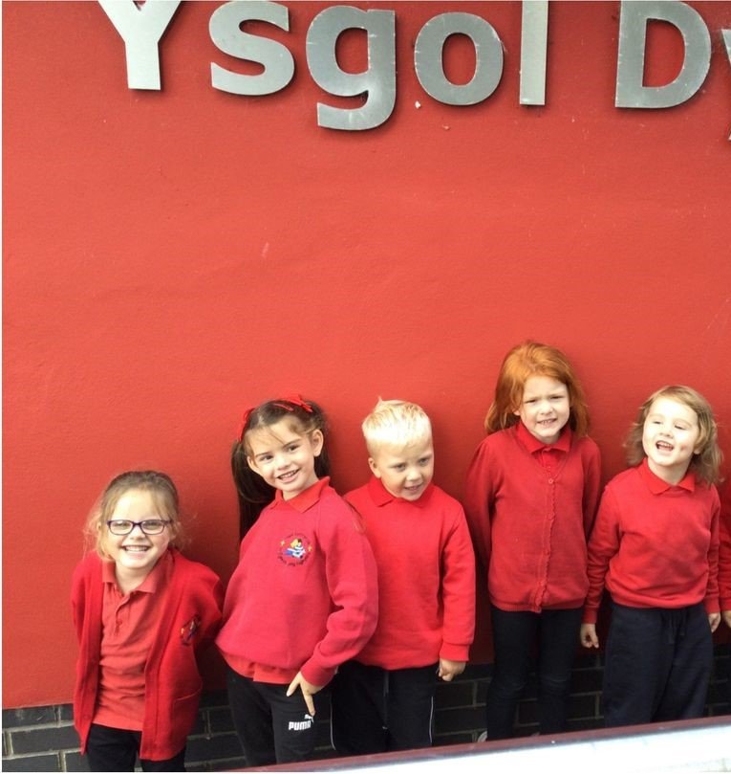

Our 2025 Reception Class

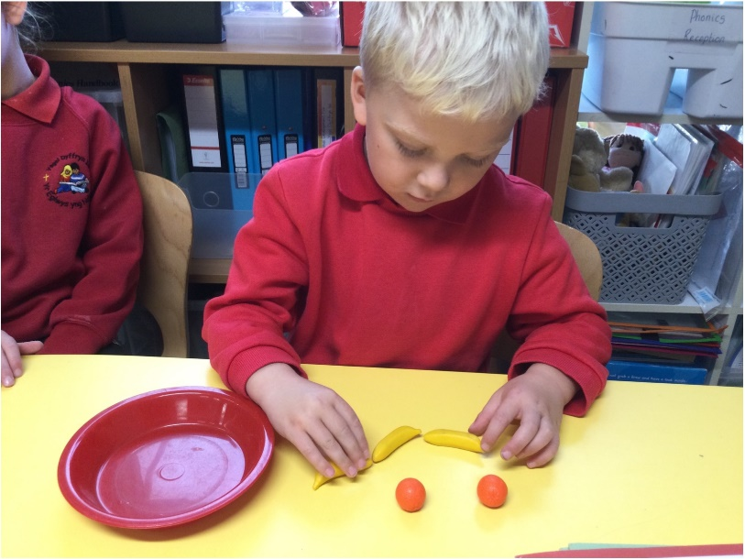

This school is a fantastic school to have your children in. They all go above and beyond. Thank you.
Parent

Starting School for the First Time

Starting school is a very important time for you, your child and the school. We all need to work together to make transition smooth and rewarding.
In the term prior to their entry, you and your child will be invited into school for an introduction meeting. This will help you become familiar with the surroundings and routines of school. During this meeting, there will be an opportunity for parents to discuss our partnership with you and talk about any worries you might have.

Joining the School Later On
Sometimes children join the school when the term has started or later on in their school life. We make every effort to make sure that they are welcomed, looked after, and monitored so that they quickly make friends and can find their way around the school. Teachers give pupils time to settle in before assessing their academic ability. This assessment, together with records from the previous school will enable your child to have the best start in school. Parents are asked to contact the school if their child has a problem settling. We promote the partnership with parents.

Transition
We have a very good relationship with the local Secondary School, Ysgol Brynhyfryd and the upper juniors will visit for various activities during the year. At the end of Year 6, the children will have the opportunity for a more formal visit to prepare them for September. There will be an opportunity for the parents to meet some of the staff, the aim being to ease the transition for all concerned. At the beginning of Year 6, you will receive information regarding schools and how to apply to the Local Authority should you wish your child to attend a different secondary school.
Leaving School
If someone other than the main parent or carer is picking up a child at the end of the school day please inform the class teacher/member of staff. If arrangements change during the day please contact the school office who will inform the teacher. It is extremely important that your child’s teacher knows exactly who will be collecting your child from school at all times. Also, please ensure that it is someone over the age of 18. Thank you for your co-operation in ensuring the safety of our children.

I would highly recommend this school and I do. Passionate, caring, professional and always make time for each child needs. Always happy thriving children when visiting.
Parent

Safeguarding

At Ysgol Dyffryn Iâl, we adhere to the All Wales Child Protection Procedures. The Headteacher (Mr. Shaun Valentine) is the Designated Lead Teacher for Child Protection, assisted by the Senior Teacher (Mrs Ruth Barber) and Teacher (Mrs Sian Wilkinson) and Governor (Mrs Pat Downes). All staff and volunteers have a current DBS certificate and receive safeguarding training. The school co-operates with Children’s Services to ensure the safeguarding of all pupils. If concerns are raised about a pupil or family, contact is made with Children’s Services and, if advised, a referral for Child Protection or Child In Need will be made.

School Security
All doors into the main body of the school are locked from the inside during lesson times. All visitors report to reception and if entering the school, they are requested to sign the log book.
CCTV cameras are at strategic positions and monitors the school grounds. Images are being monitored and recorded for the purposes of crime prevention and public safety.

Data Protection
The school has a Data Protection policy which details the arrangements for secure storage of pupil records and images. Parents are invited to give permission for photos to be used in school, on the website or in the press each year. Parents are permitted to take photos and videos at most school events but are requested not to upload photos onto the internet, including social media. Parents are also strongly advised not to discuss pupil wellbeing on social media. Please report all concerns to the class teacher or Headteacher promptly.

Behaviour

Ysgol Dyffryn Iâl prides itself on being a happy school. We have few rules. Those we do have are to enable school community to work safely and harmoniously together. Some rules are based on our expectations and on respect, along with having care for one another and personal property.

The rules of the school are agreed with the children and staff. There are rewards for good behaviour and effort and sanctions are applied when rules are broken, or behaviour deemed unacceptable.

Where a child experiences difficulty in conforming to acceptable standards of behaviour. Parents are informed and invited to discuss the matter with the Headteacher.

We aim to encourage children to accept responsibility for their own actions and try to help them understand the consequences of their behaviour and the reason why certain behaviour is unacceptable.

The ethos of the school is one where positive reward outweigh sanctions and where self-discipline is the key to effective learning. We seek your co-operation in supporting the Behaviour Policy.

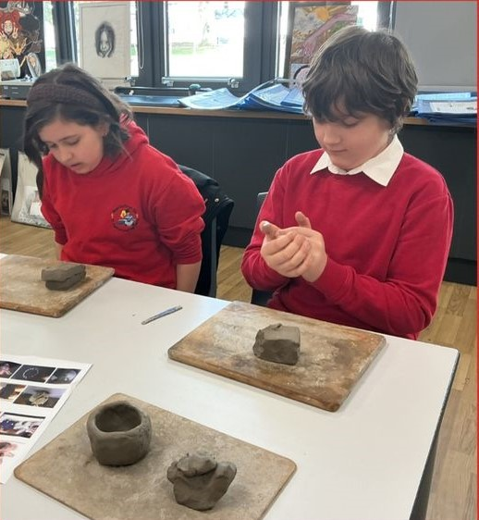
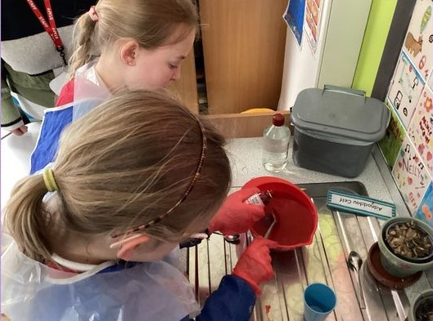

Recent parent comments

My children both loved the school and have come away with a love for learning. I feel that they have had a positive start to their education from Ysgol Dyffryn Ial and it will be a wrench to leave! Diolch yn fawr..

Dyffryn Iâl is a warm friendly welcoming school, the staff are very child focused and empower the children to each attain to their capabilities. They encourage and promote confidence in the children The learning environment which they have created is unlike any I have previously experienced, we feel very blessed that our child attended this school. We have friends and family who are very envious of our child’s education journey at Dyffryn Ial

Fantastic school with wonderful teachers and caregivers which is evident in happy and well-balanced children.
The School is outstanding!

Attendance

It is inevitable that there will be times when your child will need to be absent from school. It may be because of a visit to the doctor, dentist, opticians, etc. Whilst we would ask that, where possible, most of these appointments are made outside school hours, we acknowledge that in certain circumstances it is not possible. At these times, it will be necessary to inform the school prior to the appointment.
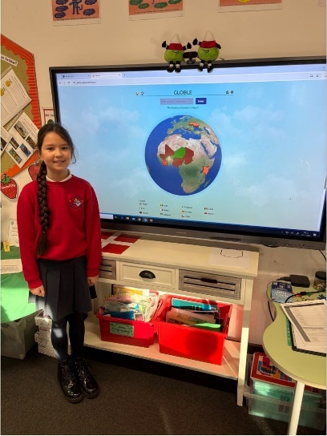

Please contact the school immediately if your child is absent. The school has a first day response policy and will phone or email parent or carers if the absence is not communicated to the school.

The number of unauthorised
absences from school will appear on your child’s report. Letters are sent
to parents where attendance falls
below 90%.
This is part of our ongoing
commitment to communication.
Please understand that children
cannot reach their potential academically and socially if
attendance is low.

Ysgol Dyffryn Iâl follow Denbighshire County Councils policy on holidays.
If you decide to take your child on
holiday during term, they will be marked unauthorised unless they
are exceptional circumstances. If
your child has more than 10 unauthorised absences, you may be fined.
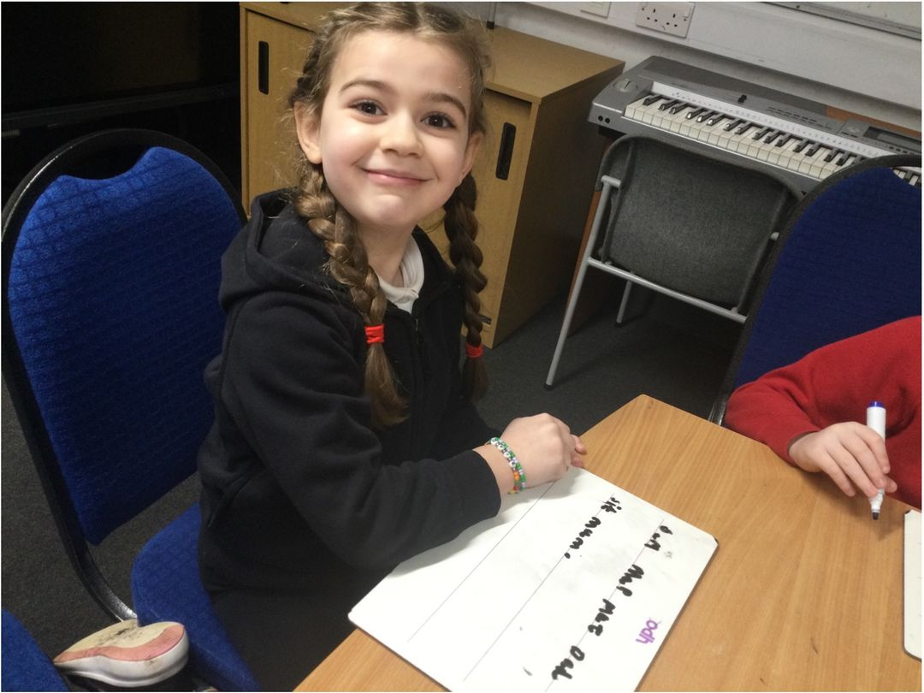

Uniform and P.E. Kit

The school uniform consists of a red sweatshirt or cardigan with a school logo, a white top, grey/black trousers, skirt or pinafore and shoes. Pupils are expected to wear sensible, strong, black shoes. The school sweatshirts are available from Sarah’s Embroidery.

Unacceptable clothing should not be worn in school; this includes jeans, denims, sports tops, jogging bottoms, tracksuits, strappy tops, trainers etc.

All children need to change into red-shirt, black shorts/skirt and suitable footwear; pumps or trainers, for P.E. lessons. Teachers will be pleased to advise about what items are appropriate for different activities. Parents/carers are responsible for ensuring their children have appropriate kit in school on the right day.

All items of clothing should be clearly marked with the child’s name. Contact the School Office if you wish to inspect any lost property.

We do have a ‘swap shop’ where you can swap uniform or just help yourself to any spare uniform on the rail.
Jewellery

For safety reasons the children should not wear jewellery to school. Any child with pierced ears should wear small studs and nothing else. Denbighshire County Council recommends that all jewellery be removed during P.E., games, swimming and drama sessions.

Micropore tape should be used to cover any earring studs that are difficult to remove, but parents should be aware that the School cannot take responsibility for any jewellery related injury.

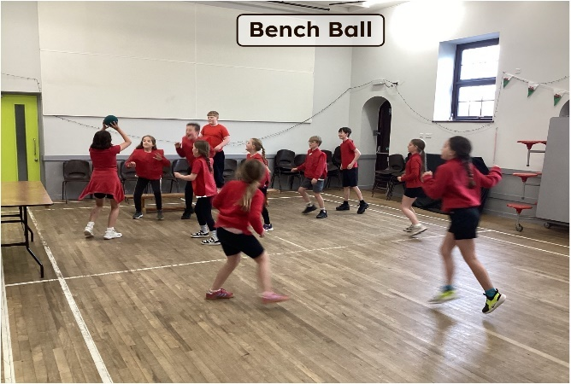

Sporting and Extra-Curricular Activities

At Ysgol Dyffryn Iâl we aim to involve children in as many activities as possible.
We praise and encourage the children for their activities outside as well as within school. During the school day we provide the following activities for the children: Football, Netball, Gymnastics, Dance, Cricket, Rounders, Athletics, Outdoor Education and Real PE.

The school offers a range of after school clubs for children. This could not take place without the commitment of all the teaching and non-teaching staff at the school. We also welcome parents who offer valuable help and expertise.

Clubs currently include craft club, sports club and a performing arts club.
Residential Trips

At Ysgol Dyffryn Iâl we offer a variety of residential trips. For Year 3 & 4 we offer a 1 night overnight stay at Pentrellyncymer. Here they enjoy building dens, cooking marshmallows, canoeing, wall climbing and gorge walking.

For Year 5 & 6 we alternate every year. One year we will visit Glanllyn and the following year we will visit Cardiff.

In Glanllyn the children have a fantastic opportunity to do many outdoor activities such as wall climbing, high ropes, raft building, canoeing and many more.

In Cardiff the children explore the city and have visited the Senedd, Millennium centre, Principality Stadium and enjoyed a boat trip.

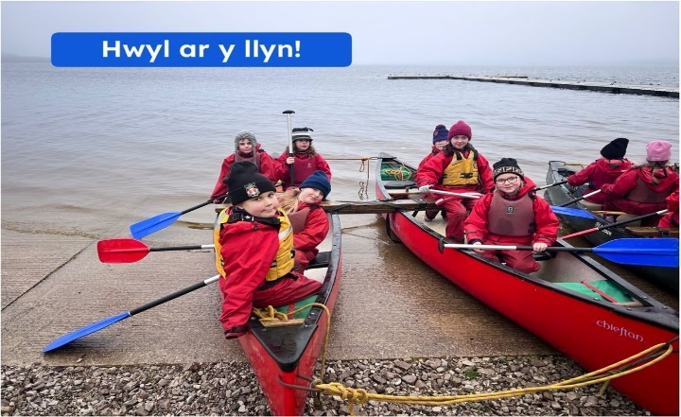

School Council and
Eco Council

Pupils in Years 2-6 apply to become School council or Eco Council members at the beginning of each school year. Classes vote for a pupil from each year group to represent them. The committees represent the views of the pupils in school and may be approached for help or ideas at any time.

The children run regular committee meetings where ideas are discussed on topics such as fundraising, playground activities and our school environment.

The School Council and Eco committee representatives report back to the children in their class on decisions made during the meeting. Committee members have responsibilities in school and they help children with problems. They also invite suggestions to improve any aspect of school life. Older members of the committees are given specific positions, such as chairperson and secretary, and use a display board to present the minutes and agenda of meetings.
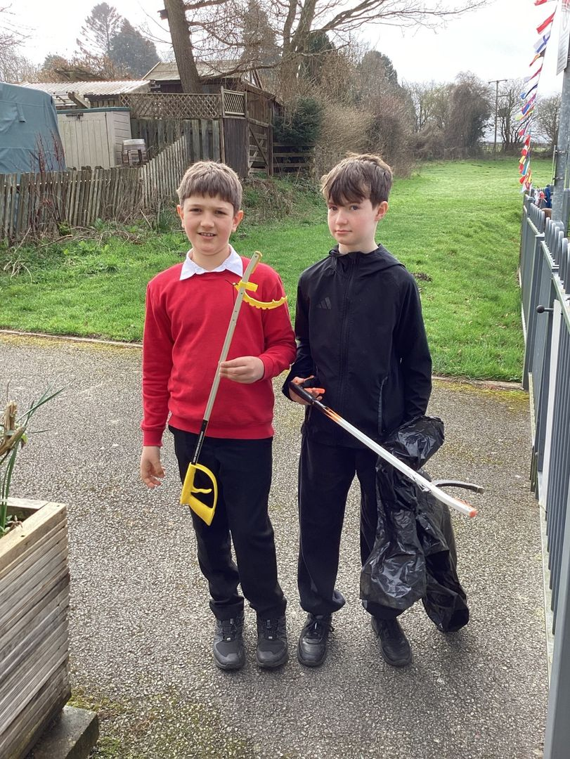
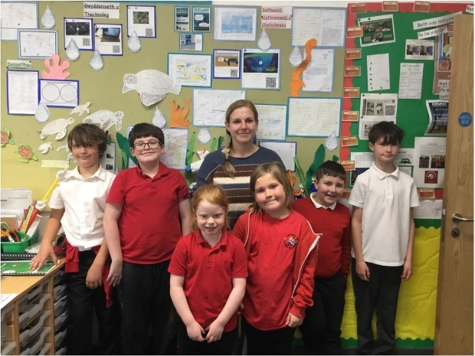

Collective Worship
We endeavour to ensure that all who take part in our Acts of Collective Worship, whatever their faith or religious background, will feel comfortable. Assemblies are led by the Headteacher, staff, Mr John Gambles, outside visitors and by children. Our daily Act of Collective Worship is an important part of the school day providing us with a forum to celebrate, contemplate and consider together. Parents/carers who do not wish their children to take part in assembly have a right of withdrawal and should write to the Headteacher if they wish to exercise this right.

As a Church in Wales School our school has a strong relationship with St. Tecla Church in Llandegla and we visit the church every Friday for our Collective Worship. We also have a strong link with St. Tysilio’s Church in Bryneglwys. We attend both Churches to hold Harvest, Easter and Christmas celebrations.

Religion, Values and Ethics
The school’s programme for Religion, Values and Ethics follows the agreed County syllabus for R.E. This reflects that the religious traditions of this country are, in the main, Christian but considers the teachings and practices of other principal religions.

We aim to:

- explore and develop pupils’ own life experiences
- help children understand and appreciate that some people have religious beliefs and show how these are put into practice
- develop in children respect, understanding and empathy for beliefs that may be similar or different from their own and help them recognise the stance of non-believers.
Lead children to appreciate their own local environment and to respect and be responsible for the wider world.

Forest School

Discover. Explore. Grow.

Learning comes alive when children step outside.

We are proud to be a Forest School, which is lead by Mrs Alys Williams our qualified Forest School Leader. Our Forest School gives every child the opportunity to learn, explore and grow in the great outdoors.
Our Forest School is an extension of the classroom – a place where children can discover, investigate, create and challenge themselves through hands-on experiences in nature. Learning is child-led and develops from the children’s own interests, ideas and natural curiosity.

🌿 Learn through adventure
From building dens and identifying wildlife to creating natural art, cooking outdoors and learning to use tools safely, every Forest School session brings new opportunities to learn.
Children are encouraged to ask questions, follow their curiosity and discover things for themselves.

🌳 Confidence to try
Forest School helps children develop the confidence to take on new challenges and the resilience to keep going when things don't go to plan.
They learn to make decisions, solve problems, manage appropriate risks and celebrate their achievements.

We don't just teach children what to think – we give them opportunities to discover for themselves.

🐾 A love of the natural world
Our children experience the changing seasons first-hand and develop a growing understanding of the plants, animals and habitats around them.
Through exploration and play, they learn to respect and care for the environment and develop a lifelong connection with nature.

🔥 Memories that last
Some of childhood's most memorable moments happen outdoors.
Whether it's building a shelter with friends, finding a tiny creature beneath a log, splashing through autumn puddles or gathering around a fire, Forest School creates experiences that children remember long after the school day is over.

Every child. Every season. Every opportunity to grow.
At our school, Forest School is about developing the whole child – nurturing curiosity, independence, resilience, creativity and confidence alongside a love of learning.

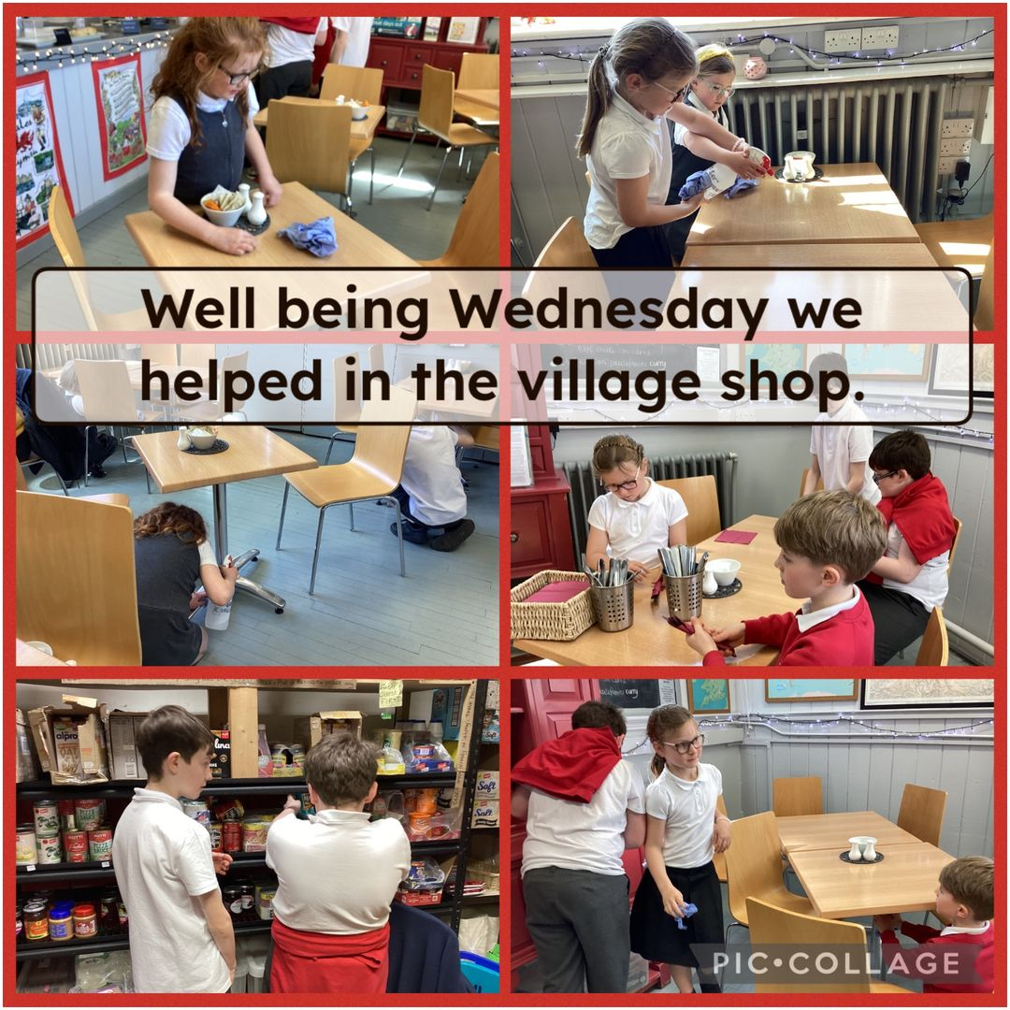
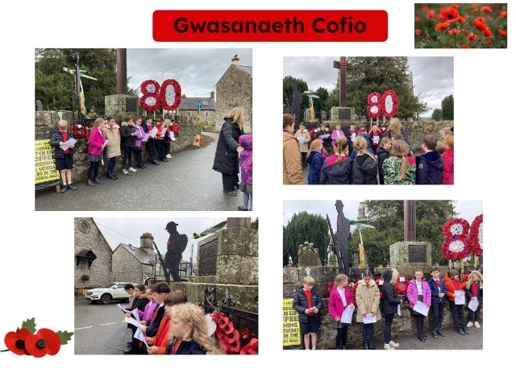

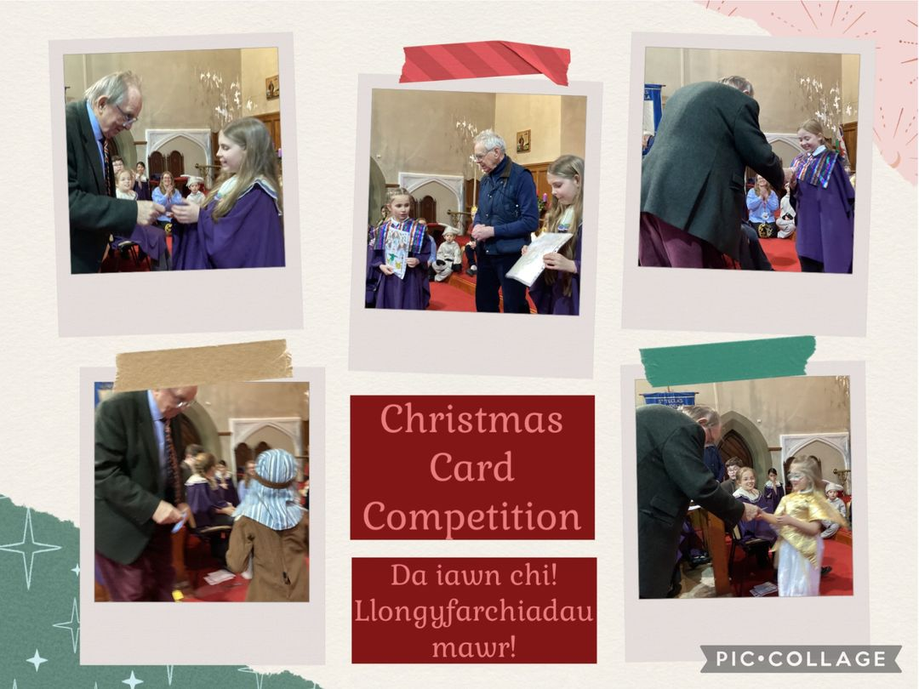
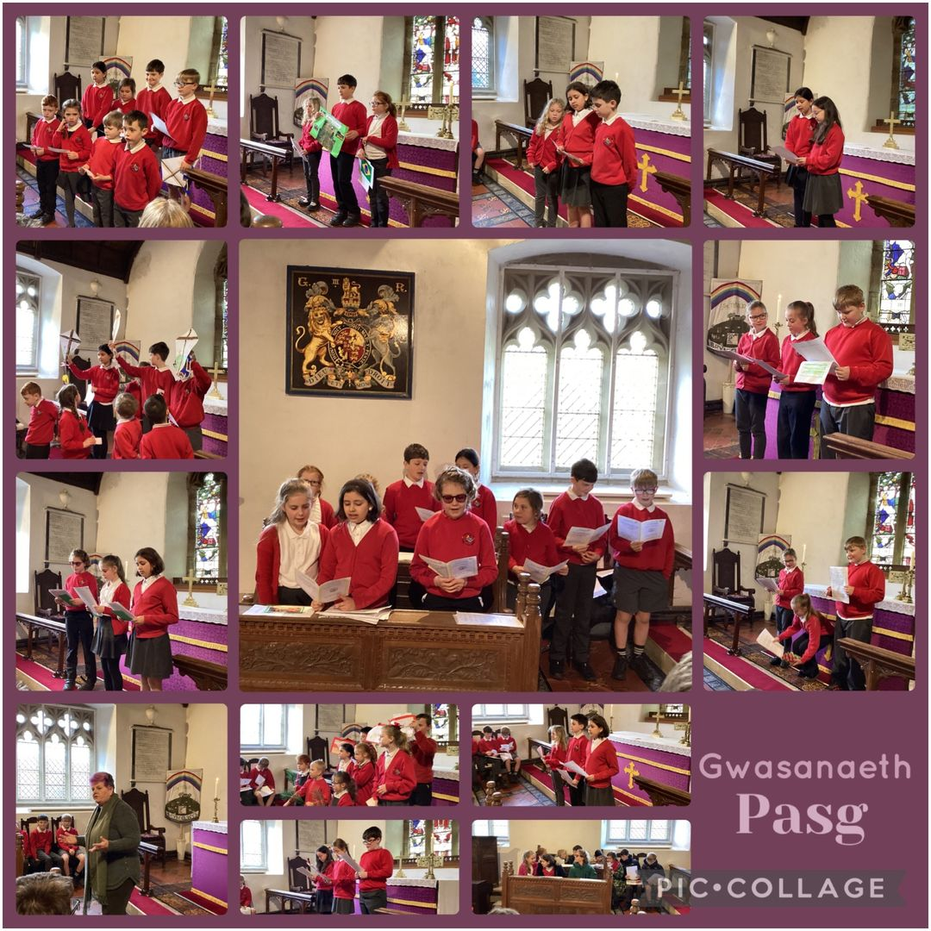

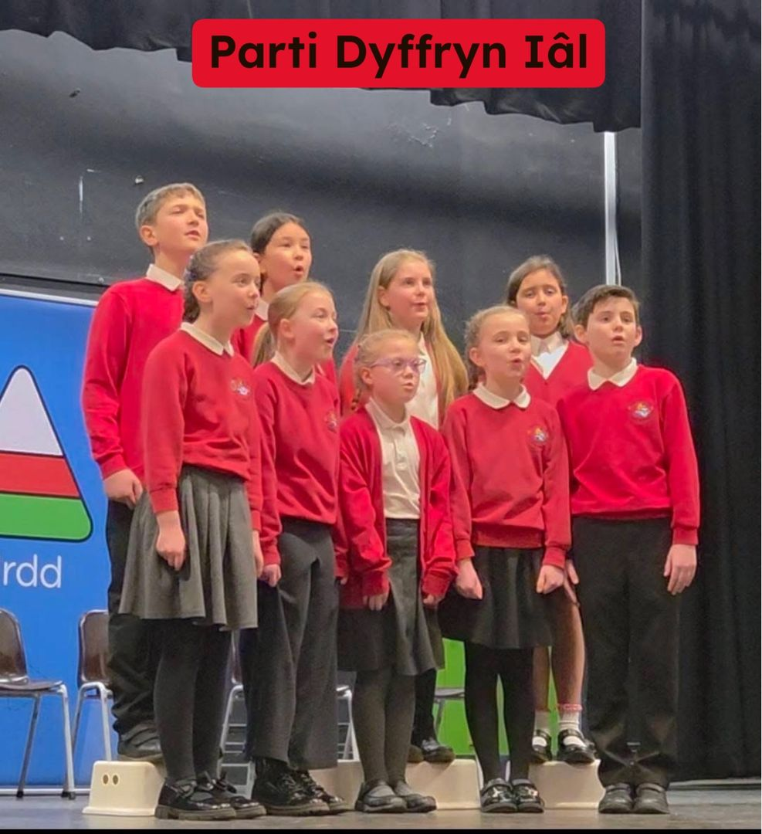
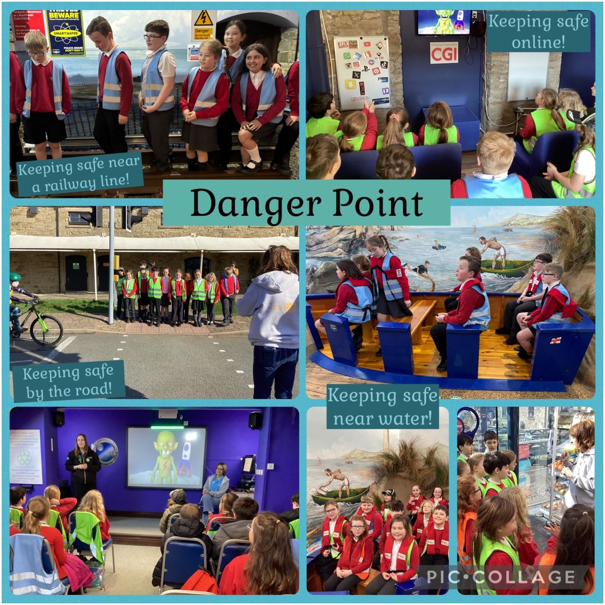

Yr Iaith Gymraeg / The Welsh
In line with National Assembly of Wales policy Welsh is included in the
curriculum throughout the school in a move towards bilingualism. Children participate regularly in Welsh oracy sessions to develop confidence and vocabulary, in addition to focused lessons and the use of incidental Welsh which is encouraged throughout the school throughout the day.

As a school in Wales, we take great pride in representing our nation’s language and heritage through the use of music, dance and crafts.

The children enter a variety of Urdd competitions to consolidate their Welsh language and culture. We also have our own annual Eisteddfod to celebrate St David’s Day.
Welsh Medium Provision Category
Ysgol Dyffryn Iâl was placed as a Welsh medium category 4 provision school. This means: Pupils in the Foundation Phase experience the areas of learning in both languages but with greater emphasis on English. In Key Stage 2, both Welsh and English is used in teaching but there is a greater emphasis on English. Welsh is used as the medium of teaching or learning for between 20% and 50% of the primary curriculum overall.
Welsh Assembly Government have now changed the categorisations and Denbighshire County Council have placed us into the Transitional 2 stage. This gives the school 10 years to plan and further increase Welsh in the school through the curriculum and extra-curricular clubs. For more details on this, please read the ‘Guidance on school categories according to Welsh-medium provision.

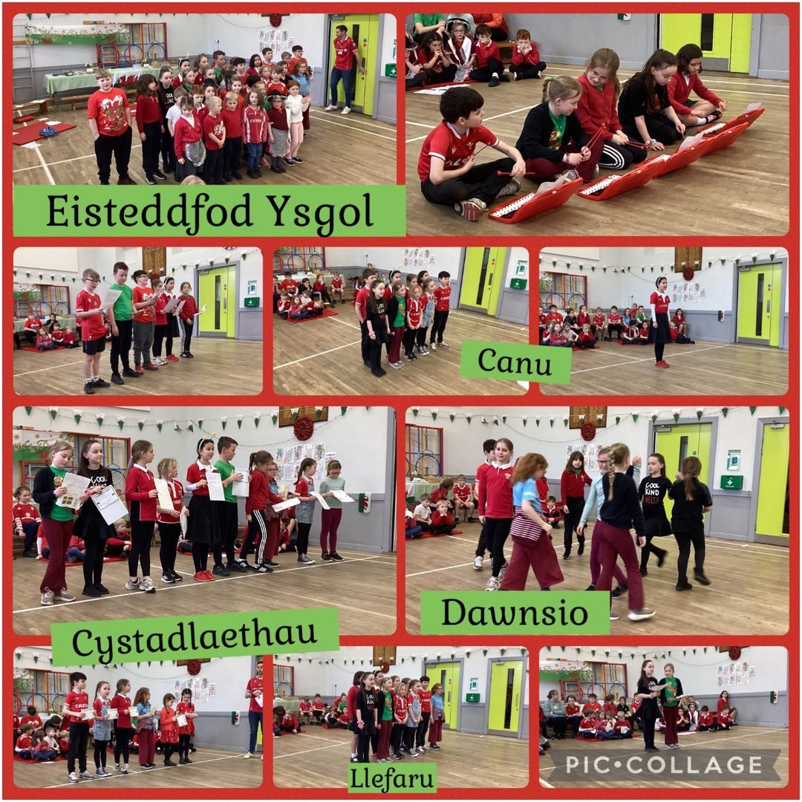

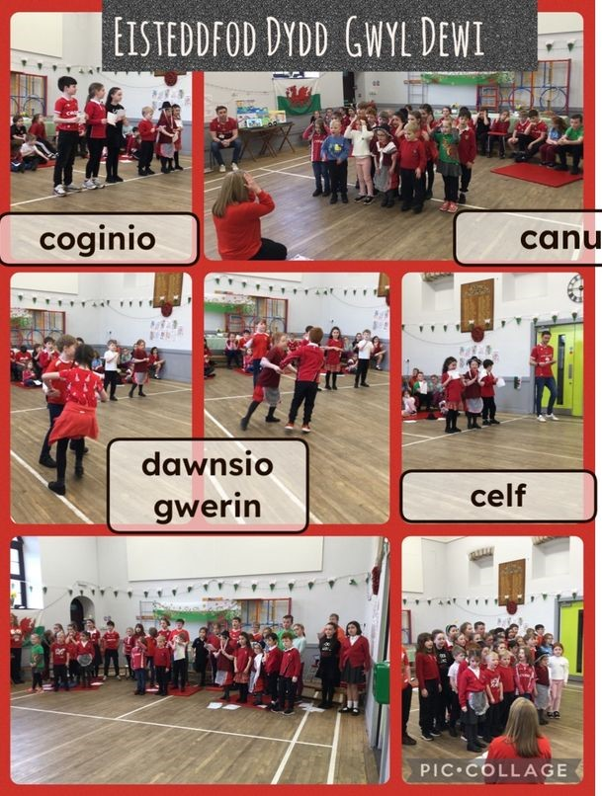

Relationships and Sexual Education (RSE)

This subject is treated with sensitivity at Ysgol Dyffryn Iâl. RSE is considered to be part of the child’s personal, social and health education programme, and as such, is introduced as part of the thematic work carried out by the school. It involves discussions about caring, dealing with feelings, keeping safe and healthy, making decisions, family life and the care of the body. These topics are dealt with when they link naturally with planned work from other subject areas and the content is always carefully matched to the needs, age and maturity of the child.

Charging and Remissions Policy

No charges are made for day-to-day school activities. These costs are met from the school’s delegated budget. The school seeks to attract extra funding from a variety of sources to help to meet the costs of activities that further enhance curriculum provision and the learning opportunities presented to children. When costs or subsidies cannot be met from these sources, parents/carers are invited to contribute towards the expenses incurred. Sometimes, if insufficient voluntary contributions are forthcoming, the activity has to be cancelled or modified.

We aim to ensure that all children get an equal opportunity to participate in all activities. When costs are a barrier to any child taking part in the wider life of the school we endeavour to find ways to overcome the problem. Parents/carers are urged to contact the Headteacher if they find themselves in such circumstances. The Governing Body’s Charging and Remissions Policy provides further information regarding this matter.

Friends of Ysgol Dyffryn Iâl
The 'Friends of Ysgol Dyffryn Ial' is a supportive organisation. They organise many fun events for the children whilst also raising money for the school. Events include movie nights, Easter egg hunts, spooky disco and an end of year disco.
Please remember that all parents are automatically members of FOYDI and everyone is welcome to attend meetings and help at our events.

We are very grateful to the Friends of Ysgol Dyffryn Iâl for their commitment and generosity.

Complaints Procedure

If you should ever feel it is necessary to make a complaint about the school curriculum or indeed any other aspect of the school, your first point of contact would be the class teacher, then the Head Teacher. If after speaking with the class teacher you are still concerned you can contact the school and arrange to discuss any matter with the Head Teacher in the hope that it can be resolved quickly and to everyone’s satisfaction.

Should the issue still not be resolved then you can make a formal complaint to the Governing Body, preferably in writing to the Chair of Governors. It is not the role of parent governors to bring complaints from individual parents into school or to meetings. That is the responsibility of the parents themselves to follow the procedure listed above. We aim that early contact and discussion would resolve most concerns so please remember that it is always best to contact school at your earliest opportunity. The policy can be accessed in full, together with all other policies and procedures, from the school office.

The Governing Body has adopted the complaints procedure outlined by Denbighshire County Council. A full copy of the school complaints policy and procedures is available by request from the school office.

A policy statement on bullying is available to all parents. A full copy of the school Anti-bullying policy and procedures is available from the school.

Governors
Governors help provide the best possible education for pupils at school Their main role is to raise standards and to monitor progress against targets that have been set.
The governing body at Ysgol Dyffryn Iâl is a group of people responsible for the strategic running of a school. They are comprised of the headteacher, staff governors, parent governors, community governors and governors appointed by the local authority.
Governors carry out their duties voluntarily and their role is to hold the headteacher to account for the running of the school and the progress and well-being of its pupils and staff.

•Governors hold a shared vision for the school which is clear, understood and well communicated to staff, parents and pupils.

•The governing body sets the strategic direction of the school and has a central role in the leadership of the school.
•Governors are confident in providing high levels of professional challenge to hold the headteacher to account.
•The governing body is successfully focused on raising standards and promoting the personal development and well-being of all learners.
•Governors have a clear understanding of the strategic priorities for the school and ensure an appropriate plan is in place and implemented effectively.
•Governors engage effectively with parents, pupils and staff and are well informed about their views and use this to inform strategic priorities for development planning.
•The governing body has a good understanding of the quality of provision within its school and how the school’s performance compares locally and nationally.
•Governors are fully and systematically involved in the evaluation process, keeping the work of the school under review and acting upon their findings.

The present Governing body members are as follows:

Name | Governor Type
Mrs. Claire Livingston (Chair) | Community Governor (Llandegla)
Mrs. Pat Downes (Vice Chair) | Community Governor (Bryneglwys)
Mr. Shaun Valentine | Headteacher
Mr. Martyn Walsh | Foundation Governor
Mrs. Shurrelle Jones | Local Authority Governor
Mr. Mike Griffiths | Parent Governor
Mr. Adam Butler | Parent Governor
Mrs. Sandra Hampson | Staff Governor
Mrs. Sian Wilkinson | Teacher Governor
Ms. Karen Bellis | Local Authority Governor

School Term Dates 2026-2027

Autumn Term
Starts: | Tuesday 1st September
Ends | Friday 18th December
Autumn half term: Monday 26th October to Friday 30th October

Christmas Holiday: Monday 21st December to Friday 1st January

Spring Term
Starts: | Monday 4th January
Ends | Friday 19th March
Spring half term: Monday 8th February to Friday 12th February

Easter Holiday: Monday 22nd March to Friday 2nd April

Summer Term
Starts: | Monday 5th April
Ends | Tuesday 20th July
Early May bank holiday: Monday 3rd May

Summer half term: Monday 31st May to Friday 4th June

Staff Training Days
1st and 2nd September 2026
4th January 2027
5th April 2027
19th and 20th July 2027

Children feel valued and this encourages them to take part in all school activities.
Estyn 2019

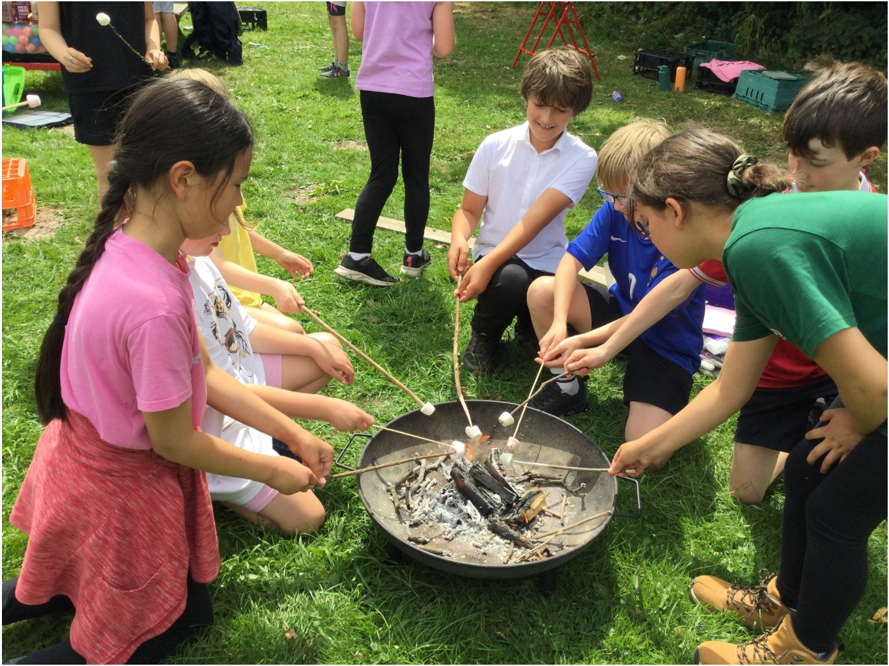

Ysgol Dyffryn Iâl
Allt Yr Efail, Llandegla,
Denbighshire,
LL11 3AW
Telephone: 01978 790645
Email: ysgol.dyffryn.ial@denbighshire.gov.uk
www.ysgoldyffrynial.co.uk

Headteacher: Mr S Valentine
Chair of Governors: Mrs C Livingston

