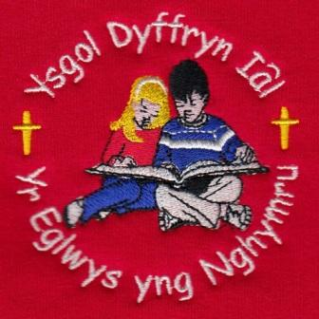
What have we been up to this week?
Dosbarth Tysilio – This week in Dosbarth Tysilio, we have been busy designing our own Christmas cards for Bishop Gregory on the theme of joy and music, and these will be displayed in Saint Tecla over the coming week. In our language work, Reception have been blending words using their new letter sounds, while Year 1 and 2 have been focusing on punctuating their sentences. In mathematics, Reception have been exploring different ways numbers can be represented and practising saying the number one more, while Year 1 and 2 have been learning about number doubles. During our digital work with Mr Valentine, we also began creating our own stop-motion animations based on the theme of superheroes.
Dosbarth Tecla – Information provided by Myfi White of year 6 and Poppy Edwards of Year 4. On Monday we began looking at Christmas in Denmark, we compared our Christmas traditions in the UK to Denmark’s Christmas traditions. We were shocked that they celebrate Christmas on 24th December. In the afternoon St Johns Ambulance came in to do a first aid workshop with us. We learnt how to do CPR and how to get into the HELP position. On Tuesday we created a diagram of the UK and Denmark’s Christmas traditions, we had to work out what was different and what was the same. We then translated Welsh words into Danish words. In Maths year 3 are working on addition and subtraction problems, year 4 are working on times tables, year 5 are converting mixed numbers and year 6 are working on fractions. We have also started learning our scripts ready for the Christmas Carol Service. On Wednesday we had sentences about Denmark and had to fill in the missing Welsh words. We then had questions, which we had to decide whether they were true or false. We also practiced our singing. In well being Wednesday Myfi made a Christmas poem and Poppy made a Christmas card. On Thursday we finished our presentations on our chosen body parts and presented them to the class. Myfi has been researching the brain and Poppy has been researching the kidneys. We continued with our maths work and also worked on our times tables. This morning we have been to Church and continued learning about advent. We then completed our comprehension and mental maths work. Later we are going swimming and then have choir practice.

28th November/ Tachwedd 2025
Attendance – Our School Target is 95%
Attendance last week – whole school 94%,
Dosbarth Tysilio 97%, Dosbarth Tecla 92.5%
Attendance for this term so far – 94.55%
Swimming Lessons – Next Friday 5th December is Dosbarth Tecla’s final swimming lesson, they will have completed 10 lessons in total. Please can parents ensure all payments are up to date. Many thanks.
Christmas Dinner – On Wednesday 3rd December all pupils are invited to come to school in their Christmas jumpers, or something colourful to enjoy Christmas Dinner.
Christmas Hampers – On Thursday 11th December there will be a non-uniform day, this can be Christmas related, but does not have to be. We kindly ask pupils to donate an item to be included in our Christmas Hampers which will be raffle prizes at our Christmas Carol Service which is a great fund raiser for the school.
School Meals – There is a change to the menu next Thursday 4th December as follows: Spaghetti and meatballs with sweetcorn and salad, followed by a blueberry and coconut square.

FOYDI Events
Guess the giant teddy name competition in the Llandegla Christmas Fayre
Christmas hamper raffle in the Christmas Concert
Dates For Your Diary

3rd December – Christmas Dinner
6th December – Christmas Fayre in the Memorial Hall.
11th December – Non-uniform day to collect donations for Christmas hampers
17th December – Christmas Carol Service – St Tecla’s Church 1.30pm

COMMUNITY
After School Club - A private After School Club is available in the Memorial Hall, contact Julie Tudor on 07984613534

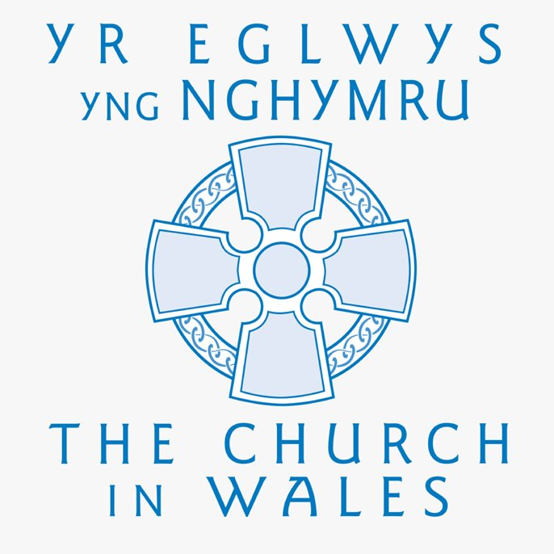

Christian Focus For
This Half Term

PEACE
WINNING TEAM THIS WEEK
IAL

Safeguarding
If you have any safeguarding concerns, please contact one of our designated safeguarding leaders Mr Shaun Valentine, Mrs Ruth Barber or Mrs Sian Wilkinson on 01978 790645.

Llythyr Newyddion Ysgol Dyffryn Iâl Newsletter
“We learn, We smile, We live, We dream together”

