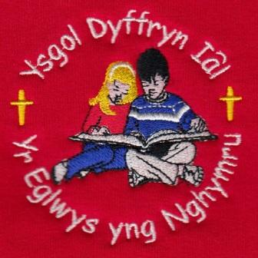
What have we been up to this week?
Dosbarth Tysilio – In Dosbarth Tysilio this week, we have been writing our own superhero poems and working hard to make them rhyme. Reception have been busy learning their new letter sounds and practising their blending. In our mathematical work, Reception have been exploring the composition of numbers, while Year 1 and Year 2 have been adding groups of objects and exploring number bonds to 20. For our creative work, Year 1 and Year 2 have been using their colour-mixing skills to create cityscape backgrounds for their superhero pictures. As part of our topic work this week, we have been finding out about the 50 US states and comparing them with the counties of Wales.

Dosbarth Tecla – Information provided by Evan Butler and Connor Sheer of Year 4. On Monday we completed our mental maths work. In our missions we created a game where you had to find cones. We continued with our Lego story and wrote our blurb. In spellings we worked on the sounds ‘ei, eigh, ey’, we had to find words that had this sound in. On Tuesday in maths year 3 were adding and subtracting, year 4 were working on multiples of 3 & 6 and years 5 and 6 began working on fractions. In our topic work we had to find places in Denmark and add them to the map. We then worked on spell blast and number blast. On Wednesday we completed the front cover of our Lego story. In missions we did some Lego and Minecraft building. We continued finding out information about Denmark, as this is where Lego was created. In spellings we had to write as many words as we could with the letters ‘ei, eigh and ey’ in them. In well being Wednesday we made a Christmas themed game and practiced our singing. On Thursday we continued our maths work and worked on our 6 timetables. The school choir practiced for the Llandegla Christmas Fayre. We then continued working on our science project, Connor is looking at the lungs and Evan is looking at the brain. This morning we have been to church and have been learning about advent. We are then going swimming to Corwen Leisure Centre. This afternoon we will be completing our maths work.

21st November/ Tachwedd 2025
Attendance – Our School Target is 95%
Attendance last week – whole school 93.7%,
Dosbarth Tysilio 94%, Dosbarth Tecla 93.5%
Attendance for this term so far – 93.73%
BBC Children In Need – We raised £34.00 for this year’s appeal. Thank you for your support.
School Arrival – If your child is arriving to school after 9am, please can a parent bring them into Reception and sign them in.
Swimming Lessons –Please can parents of Dosbarth Tecla ensure all payments are up to date. Many thanks.
Individual School Photograph – Parents can order online and have until Wednesday 26th November to place orders to take advantage of free delivery back to school. Order through Tempest website: www.tempest-orders.co.uk
Christmas Hampers – On Thursday 11th December there will be a non-uniform day and we kindly ask pupils to donate an item to be included in our Christmas Hampers which will be raffle prizes at our Christmas Carol Service which is a great fund raiser for the school.

FOYDI Events
Guess the giant teddy name competition in the Llandegla Christmas Fayre
Christmas hamper raffle in the Christmas Concert
Dates For Your Diary

25th November - Parents Evening Nursery & Reception with Mrs Barber.
3rd December – Christmas Dinner
6th December – Christmas Fayre in the Memorial Hall.
11th December – Non-uniform day to collect donations for Christmas hampers
17th December – Christmas Carol Service – St Tecla’s Church 1.30pm

COMMUNITY
After School Club - A private After School Club is available in the Memorial Hall, contact Julie Tudor on 07984613534

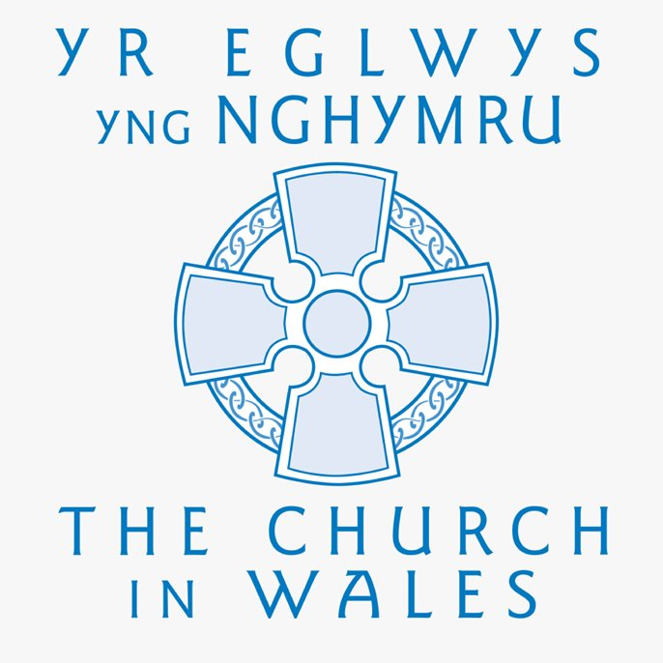

Christian Focus For
This Half Term

PEACE
WINNING TEAM THIS WEEK
IAL

Safeguarding
If you have any safeguarding concerns, please contact one of our designated safeguarding leaders Mr Shaun Valentine, Mrs Ruth Barber or Mrs Sian Wilkinson on 01978 790645.

Llythyr Newyddion Ysgol Dyffryn Iâl Newsletter
“We learn, We smile, We live, We dream together”

