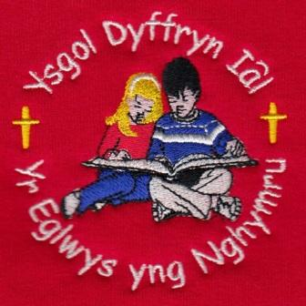
What have we been up to this week?
Dosbarth Tysilio – This week in Dosbarth Tysilio we have been busy creating our own Bonfire Night poems, using our senses and onomatopoeia to bring them to life. Year 1 and Year 2 have also been completing their comic strips, while Reception have been learning their new letter sounds i, p, and n, and have started blending simple words. In our mathematical work, Reception have been exploring the concept of “one less,” while Year 1 and Year 2 have been working on mass and practising their number bonds to 10. As part of our creative work, we have been printing poppies for Remembrance Sunday and drawing our own superheroes in the style of Roy Lichtenstein to support our topic work, we also enjoyed a visit from two local police officers who told us all about their jobs and the equipment they use.

Dosbarth Tecla – Information provided by Olly Hughes of Year 6 and Heath Kirwan of Year 5. On Monday we worked on our mental maths and times tables. We then began story planning for our ‘Superheroes’ story, we created a good and bad guy. In the afternoon we had a live lesson about ‘Remembrance Day’, and made a poster on ‘why we remember’ and poppy fields. On Tuesday we had our Remembrance Day Service at the cenotaph where Bonnie laid a wreath for Ysgol Dyffryn Ial. Olly read out a passage about Poppy Day. Then in maths year 3 were adding and subtracting, year 4 were looking at area, year 5 were working on equivalent fractions and year 6 were multiplying and dividing by 10, 100 & 1000. In the afternoon we were looking at Denmark in our topic work, as that is where Lego was created. On Wednesday we began singing practice for our Christmas Concert. We then typed up our story about ‘Superheroes’ on our Chromebook. In the afternoon we started to plan well-being Wednesday’s for the next 5 weeks. We all had to think of different ideas, and we will vote next week. On Thursday we continued our maths work. We then went to the hall and worked on mental maths, timetables and comprehension. In the afternoon we created a power point on the human body, we worked in groups of 2. We made a presentation on the intestines, which we will present to the class next week. This morning we have been to Church, then continued with our maths. We are then going swimming to Corwen Leisure Centre. The school council have created activities for Children In Need which the classes are going to do this afternoon.

14th November/ Tachwedd 2025
Attendance – Our School Target is 95%
Attendance last week – whole school 93.3%,
Dosbarth Tysilio 91%, Dosbarth Tecla 94.5%
Attendance for this term so far – 93.64%
School Choir (years 2-6) – We have been invited to sing again at the Llandegla Christmas Fayre on Saturday 6th December. An email has been sent with details, if your child is available and would like to be part of the school choir please email the school office. Thank you to everyone who has replied so far.
School Arrival – If your child is arriving to school after 9am, please can a parent bring them into Reception and sign them in.
Parents Evening – Confirmation of appointments have been emailed to parents this week.
Poppy Appeal 2024 – So far, we have raised £59.00 via ParentPay. We will advise the total amount of our fundraising to include The Royal British Legion collection box as soon as we can. Thank you for your support.
Swimming Lessons –Please can parents of Dosbarth Tecla ensure all payments are up to date. Many thanks. Children have been asked to bring old clothes to swimming for the next session.
Children In Need – Thank you for helping us to support this important annual fundraiser. Please make your donation via ParentPay.

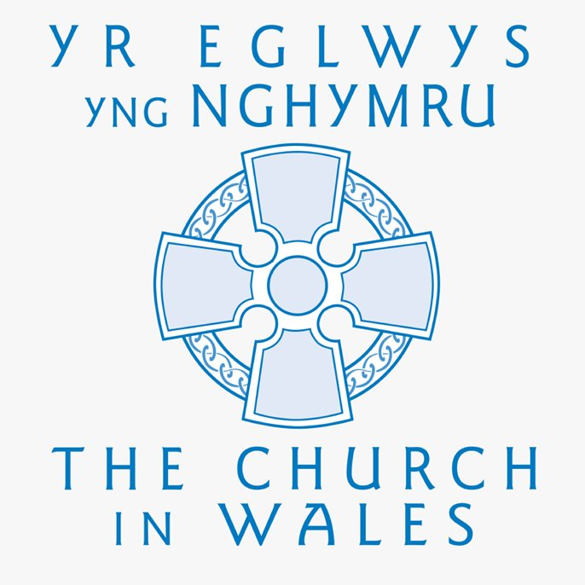

SCHOOL ADMISSIONS SEPTEMBER 2026
Reception – closing date 17th November 2025
Nursery – closing date 16th February 2026

Safeguarding
If you have any safeguarding concerns, please contact one of our designated safeguarding leaders Mr Shaun Valentine, Mrs Ruth Barber or Mrs Sian Wilkinson on 01978 790645.

Christian Focus For
This Half Term

PEACE
Dates For Your Diary

17th November – Parents Evening Years 3 & 4 with Mrs Wilkinson and Years 5 & 6 with Mr Valentine
19th November – Parents Evening Years 1 & 2 with Mrs Barber.
25th November - Parents Evening Nursery & Reception with Mrs Barber.
3rd December – Christmas Dinner
6th December – Christmas Fayre in the Memorial Hall.
17th December – Christmas Carol Service – St Tecla’s Church 1.30pm

COMMUNITY
After School Club - A private After School Club is available in the Memorial Hall, contact Julie Tudor on 07984613534

WINNING TEAM THIS WEEK
IAL

Llythyr Newyddion Ysgol Dyffryn Iâl Newsletter
“We learn, We smile, We live, We dream together”

