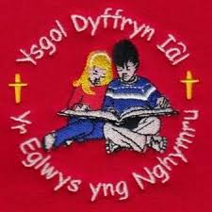
Ysgol Dyffryn Iâl
Governors’ Report to Parents 2024-25

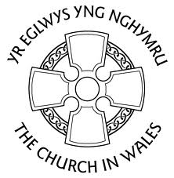
We Learn, We Smile, We Live, We Dream Together.
Dysgu, Gwenu, Byw, Breuddwydio – Gyda’n Gilad.

A note from the Chair of Governors
Mrs Claire Livingston
Dear Parents and Carers,

The new academic year is well under way and it has been my pleasure to visit school on numerous occasions since the start of September. It has been wonderful to see the pupils return to school, and I would like to take this opportunity to welcome all new pupils, and their families, who have joined Ysgol Dyffryn Iâl since September.

As Governors we take our role seriously and work as a team to ensure the schools strategic plan is followed and achieved. We meet regularly to discuss areas of the curriculum, safeguarding, school development plan and finance. We have a close working relationship with all the teaching staff ensuring that we are fully aware of how the school is performing.

Our most important priority is the children and ensuring that they have every opportunity to achieve their full potential. I believe that by working together we can provide all the children at Ysgol Dyffryn Iâl with a bright and exciting future. I am confident that all our pupils will continue to thrive and grow as individuals over the coming year, under the excellent care, and support, of the staff.

It is my pleasure to commend this Governor’s Report to you, and I wish you all a very merry Christmas and happy new year.

Claire Livingston
Chair of Governors

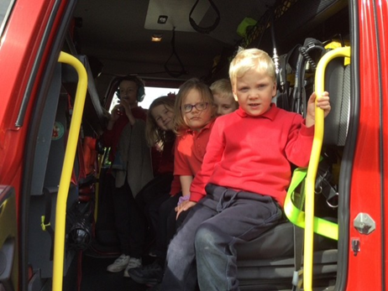
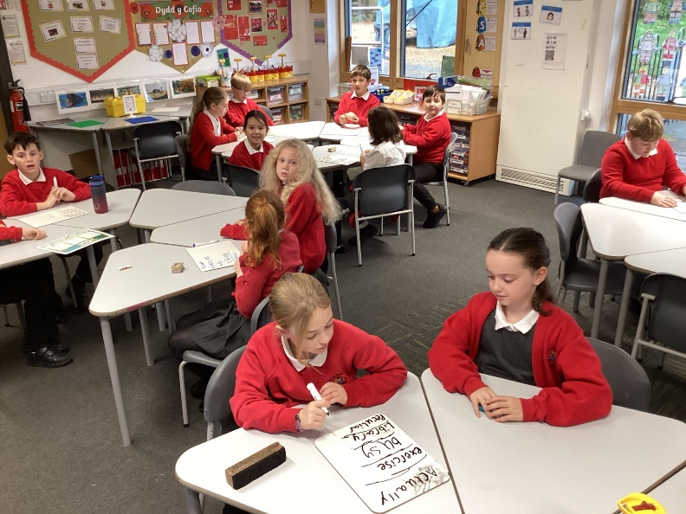
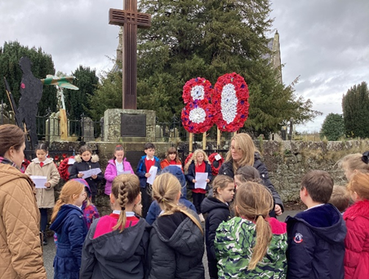

The Governing Body
- Governors help provide the best possible education for pupils at school Their main role is to raise standards and to monitor progress against targets that have been set.
- The Governing Body at Ysgol Dyffryn Iâl is a group of people responsible for the strategic running of a school. They are comprised of the Headteacher, Staff Governors, Parent Governors, Community Governors and Governors appointed by the Local Authority.
- Governors carry out their duties voluntarily and their role is to hold the Headteacher to account for the running of the school and the progress and well-being of its pupils and staff.
- Governors hold a shared vision for the school which is clear, understood and well communicated to staff, parents and pupils.
- The governing body sets the strategic direction of the school and has a central role in the leadership of the school.
- Governors are confident in providing high levels of professional challenge to hold the headteacher to account.
- The Governing Body is successfully focused on raising standards and promoting the personal development and well-being of all learners.
- Governors have a clear understanding of the strategic priorities for the school and ensure an appropriate plan is in place and implemented effectively.
- Governors engage effectively with parents, pupils and staff and are well informed about their views and use this to inform strategic priorities for development planning.
- The Governing Body has a good understanding of the quality of provision within its school and how the school’s performance compares locally and nationally.
- Governors are fully and systematically involved in the evaluation process, keeping the work of the school under review and acting upon their findings.

The present Governing body members are as follows:
Name | Governor Type | Term Ends
Mrs. Claire Livingston  (Chair) | Community Governor | 01/12/2027
Mr. Mike Griffiths  (Vice-Chair) | Parent Governor | 11/10/2026
Rev. Lynette Norman | Foundation Governor | 04/02/2029
Mr. Martyn Walsh | Foundation Governor | 11/10/2026
Mrs. Pat Downes | Community Governor | 21/02/2026
Mr. Adam Butler | Parent Governor | 01/09/2027
Mrs. Sandra Hampson | Staff Governor | 01/10/2027
Mrs. Sian Wilkinson | Teacher Governor | 01/03/2026
Ms. Karen Bellis | Local Authority Governor | 01/12/2029
Mrs. Shurrelle Jones | Local Authority Governor | 12/10/2027
Mr. Shaun Valentine | Headteacher | Ongoing

Contact Details:
Mrs. Claire Livingston, 07878 134736
Clerk to the Board of Governors: Mrs. Sian Griffiths 01978 790645

Financial Statement April 2024-2025
DESCRIPTION | ANNUAL  BUDGET  2024-25 | TOTAL EXPENDITURE 2024-25 | UNDER/  (OVERSPEND)  2023-24
BALANCE B/F | (41,247) |  | (41,247)
EMPLOYEES | 312,813 | 308,715 | 4,098
PREMISES | 39,700 | 41,413 | (1,713)
TRAVELLING EXPENSES | 300 | 0 | 300
SUPPLIES & SERVICES (Inc. Capitation) | 29,726 | 36,478 | (6,752)
THIRD PARTY PAYMENTS | 19,505 | 19,116 | 389
INCOME | (33,761) | (47,508) | 13,747
BALANCE C/F | (19,053) | 0 | (19,053)
SCHOOL TOTAL | 307,983 | 358,214 | (50,231)
SURPLUS/ (DEFICIT) FOR YEAR |  |  | (50,231)
SURPLUS/(DEFICIT) ACCUMULATIVE |  |  | (91,478)
SURPLUS/(DEFICIT) AS %AGE OF BUDGET |  |  | -29.70%

Attendances and Absences 2024-25
The Headteacher regularly monitors attendance and punctuality. Parents are asked to phone or e-mail on the first day of absence to let us know why your child is absent or late. We send out termly attendance figures for every child, with these ‘traffic lights’ categorising children based on their attendance for that term. If attendance is lower than expected, then the reasons for this are explored, and support and advice offered. If there are a number of unauthorised absences, parents will receive a letter, and a continuation of missing school without a legal and valid reason can lead to a fixed-penalty notice. Whole-school attendance for 2024-25 was 93.7%, which is below our target of 95%.

Additional Learning Needs
Mrs Ruth Barber is the ALNCo (Additional Learning Needs Coordinator) at Ysgol
Dyffryn Iâl. As part of our regular pupil tracking systems, we can identify children's strengths and weaknesses and ensure that they make the best progress.
Mrs Barber, works closely with parents and other professionals to identify and support all pupils who have additional learning needs (ALN). The school's support staff work with individuals and small groups of children on specific skills. The school also works with external support employed by the authority when required. During this year, the school has had help and advice from the Educational Psychologist, Behaviour Support and Speech and Language teams.
Children whose difficulties have been perceived to be severe are referred for a full educational assessment. This involves assessment and testing in school with input from the Local Authority and other agencies such as Health. Parents are consulted and kept informed throughout the whole process.
The school adheres to Denbighshire County policies and the national guidelines laid down in the Additional Learning Needs Code of Practice.

Equal Opportunities
We are an inclusive school, and we do everything possible to ensure that all pupils are offered the same opportunities regardless of race, gender, colour, religion, sexuality or physical ability. We have an equal opportunities policy in place to support this. The Governing Body ensures access for pupils and adults with disabilities, with us ensuring that disabled people are always treated fairly and that our school is accessible to wheelchair users. The school has a three-year Access plan. You may ask for this policy at the school office.

School Prospectus
Our school prospectus is reviewed and updated annually. It is available to prospective parents along with current parents and guardians. You can ask for a copy at the school office or visit the school website to download an electronic version.

How do I know my child is making progress?
Pupil Progress Reviews between the Headteacher and class teachers take place on a termly basis to ensure that good progress is being made by all pupils. Where good progress is not evident, we seek to identify the barriers stopping progress being made and take actions or use focused intervention programmes to try and accelerate progress.

Curriculum
The Curriculum for Wales became statutory in September 2022.
The purpose of this curriculum is to enable learners to develop the four purposes:
- ambitious, capable learners, ready to learn throughout their lives
- enterprising, creative contributors, ready to play a full part in life and work
- ethical, informed citizens of Wales and the world
- healthy, confident individuals, ready to lead fulfilling lives as valued members of society
The curriculum is taught through 6 areas of learning and experience:
- Expressive Arts
- Health and Well-Being
- Humanities
- Languages, Literacy and Communication
- Mathematics & Numeracy
- Science & Technology

A curriculum is important to every school and its learners. When designing Ysgol Dyffryn Iâl’s curriculum we have ensured that learning experiences will be engaging, relevant, challenging and motivational to children in the classroom and beyond.
Our aim is to provide high quality teaching experiences which will ensure our learners are ambitious, enterprising, ethical and healthy citizens.
Our appealing and engaging topics, together with pupil voice, will allow learners to have opportunities to work in ways that enhance their learning and also present their work in their own unique and personal way. We are also in the process of becoming a Forest School, with our younger class Dosbarth Tysilio now having started weekly sessions with Mrs Williams.

School Policies
The staff and Governors have prepared and approved a series of policies. These policies have followed the national/local guidance in many cases. Copies of relevant policies and information can be found on the school website or by request from the school office. Policies are monitored, reviewed and if necessary, adapted at set timescales or when updated guidance becomes available.

Yr Iaith Gymraeg – The Welsh Language
Ysgol Dyffryn Iâl has been designated as a Welsh medium category 4 provision school by Denbighshire County Council. Under the ‘Defining schools according to Welsh medium provision’ document, this means:
- Pupils in the Foundation Phase experience the areas of learning in both languages but with greater emphasis on English.
- In Key Stage 2, both Welsh and English is used in teaching but there is a greater emphasis on English. Welsh is used as the medium of teaching or learning for between 20% and 50% of the primary curriculum overall.
- In line with National Assembly of Wales policy, Welsh is included in the curriculum throughout the school in a move towards bilingualism.
- Children participate regularly in Welsh oracy sessions to develop confidence and vocabulary, in addition to focused lessons and the use of incidental Welsh which is encouraged throughout the school throughout the day.
- The children enter a variety of Urdd competitions to consolidate their Welsh language and culture. We were very proud to participate in the national Eisteddfod at Parc Margam in Port Talbot earlier this year. We also have our own annual Eisteddfod to celebrate St David’s Day.

Sports and Extra-Curricular Opportunities
At Ysgol Dyffryn Iâl we aim to involve children in as many activities as possible. We praise and encourage the children for their activities outside as well as within school.
During the school day we provide the following activities for the children: Swimming, Football, Netball, Rugby, Gymnastics, Dance, Cricket, Rounders, Athletics, Outdoor Education and Real PE.
The school has offered a range of after school clubs for children, and will be looking at how we can continue this after Christmas with pupils to be consulted on the types of clubs they want. This could not take place without the commitment of all the teaching and non-teaching staff at the school. We also took part in competitions against other schools in athletics and netball.
Residential trips included:
Years 3 & 4 completing a 2-day residential trip to Pentellyncymer.
Years 5 & 6 completing a 3-day residential trip to Glanllyn.
Years 5 & 6 will visit Cardiff for a 3-day residential trip in June 2026.

Community Links
Ysgol Dyffryn Iâl understands and values the importance of Community involvement and involves itself in many different areas. The school has strong links with the church and hold weekly Collective Worship services and celebrations at St Tecla Church.
We hold Harvest, Christmas and Easter services at St Tecla Church, Llandegla and St Tysilio, Bryneglwys. Our services and concerts are well attended by pupils, family and friends as well as members of the community.
Ysgol Dyffryn Iâl work closely with the police. Our School Liaison Officer visits our school and covers many topics such as Cyber-bullying, internet safety, bullying, anti-social behaviour and drugs.
The school actively involve the parents and community in education. We link with other primary schools to enhance the curriculum. The school are involved in inter-school sporting events and other inter-school opportunities.

Communication
The school have many means of communication with parents and the community:
- Weekly Newsletters – each Friday the in-depth school newsletter is circulated. Parents can receive the Newsletter through e-mail or visit the school website.
- Website – The school website is a good source of information for parents. The website includes day-to-day information, policies, staff and governor information etc.
- Parent Evenings are arranged in the autumn term and Spring Term to discuss children’s progress. Parents have an opportunity to look through their children’s book during this evening.
- End of year reports are distributed in July with parent and child feedback requested. An additional Parents Evening is arranged for any parents wishing to discuss their child’s report.
- The school use email and the ‘Seesaw’ app to communicate with parents, with Seesaw mainly utilised as a platform for children to showcase their work.

Our PTA - Friends of Ysgol Dyffryn Iâl (FOYDI)
The school is very fortunate to have 'Friends of Ysgol Dyffryn Ial' who are active and arrange many fun events for the children, whilst also raising money for the school. Events include movie nights, Easter egg hunts, a spooky disco and an end of year disco. Please remember that all parents are automatically members of FOYDI and everyone is welcome to attend meetings and help at our events.

Estyn Recommendations
In October 2019, Ysgol Dyffryn Iâl were inspected by her Majesty’s Inspectorate Estyn. The school were given two recommendations as targets for improvement. These were:
- R1 - Sharpen monitoring processes so that they focus consistently on evaluating the progress pupils make and the standards they achieve.
- R2 Build on the existing good practice and outcomes in order to achieve strong, sustained performance and practice.
School Development
The school is constantly striving to improve standards and the quality of learning and teaching for all our children. Each year, staff review the curriculum and the standards that the children have achieved and we set targets for improvement. These are written in the School Development Plan (SDP).

The school priorities for 2024-25 were:
1. To further develop and enhance the integration of the Religious, Values, and Ethics Curriculum.
2. To further enhance learners' Welsh language oral skills across the school.
3. To ensure effective planning of outdoor learning opportunities across the curriculum.
Transition
The school's partner high school is Ysgol Brynhyfryd. Some of the children attend Ysgol Dinas Bran as a preferred placement.
To help prepare the children for the move to high school, we have regular
transition events which usually begin when children are in Year 5.

School Committees & Healthy Schools
School Councillors, Eco-Councillors and Criw Cymraeg are elected each year by the pupils. We work hard to be a healthy school. We constantly encourage healthy eating and drinking, regular exercise, anti-bullying and positive behaviour strategies.
All school staff work together to provide opportunities for pupils to voice their concerns, offer their views and suggestions and be involved with general school development.
The School Day
Times during our school days are as follows:
- Morning - 9:00 to 12:00
- Afternoon - 1:00 to 3:15
- Nursery PM – 12:45 to 3:15
Toilets
There is a block of toilets for Dosbarth Tysilio (3-7 year olds).
In Dosbarth Tecla there is a block of toilets for boys and a block of toilets for the girls.
The toilets are checked frequently during the school day and any operational or cleanliness issues are addressed promptly by the staff.

Security
The school is linked to the main alarm system and CCTV cameras are placed at strategic positions around the school. Anyone coming onto the school premises during the day is required to report to the main office on arrival. This ensures that any visitors or parents do not enter classrooms without permission and pupils are not disturbed during lessons.

Complaints Procedures
A formal complaints procedure exists and may be obtained from the school website or from the school directly, should the need arise. It is hoped that parents would approach the class teacher and/or Headteacher with any concerns well before the necessity for such action to occur.

School Term Dates 2025-2026
Autumn Term
Starts: Monday 1st September 2025
Ends: Friday 19th December 2025
Autumn half-term: Monday 27th October to Friday 31st October 2025
Christmas holiday: Monday 22nd December 2025 to Friday 2nd January 2026

Spring Term
Starts: Monday 5th January 2026
Ends: Friday 27th March 2026
Spring half-term: Monday 16th February to Friday 20th February 2026
Easter holiday: Monday 30th March to Friday 11th April 2026

Summer Term
Starts: Monday 13th April 2026
Ends: Monday 20th July 2026
May Bank Holiday: Monday 4th May 2026
Summer half-term: Monday 25th May to Friday 30th May 2026

Staff Training Days
Monday 1st September 2025
Tuesday 2nd September 2025
Friday 24th October 2025
Monday 5th January 2026
Friday 12th June 2026
Monday 20thJuly 2026


