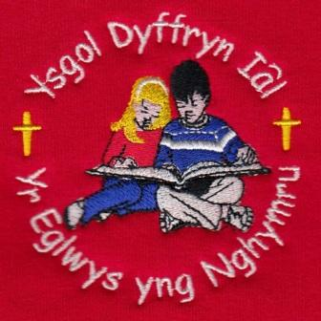
All the staff at Ysgol Dyffryn Ial would like to wish all our pupils and their families a lovely Christmas and we will see them back in school in January.

19th December/ Rhagfyr 2025
Attendance – Our School Target is 95%
Attendance last week – whole school 83.7%
Dosbarth Tysilio 85.9%, Dosbarth Tecla 82.6%
Attendance for this term – 93.67%
We are delighted to welcome two new pupils this week to Dosbarth Tecla. A warm welcome to Noah and Eira.
Christmas Carol Service – Thank you to everyone who was able to join us on Wednesday for a very festive service. I think you would agree that all the children were fabulous.
Pantomime Trip – All the children and staff thoroughly enjoyed the pantomime this morning. Thank you to FOYDI for making this possible.
FOYDI – A huge £226.35 has been raised from the raffle at the Christmas Carol Service and ‘name the highland cow’ at the Christmas Fayre. Thank you to the PTA, we value all your support.
Sadly, we are saying farewell to Mrs Louise Arthur this week, thank you for all your hard work over the last 2 years and we wish you all the best for the future.


What have we been up to this week?

This week has been very busy in Dosbarth Tysilio and Dosbarth Tecla.
- We performed our Christmas Carol Service in St Tecla’s Church in front of our family members.

- We have been making Christmas cards, Christmas bags and hot chocolate cones.

- The winners of the Christmas card competition were George Davies, Millie Edwards, Imogen Griffiths, Poppy Edwards, Bonnie Smith and Myfi White. With a special mention to Imogen and Myfi who were highly recommended in the Bishop’s Christmas card competition.

- Beatrice Palmer won guess the name of highland cow with the name ‘Indigo’.

- We enjoyed the ‘Wizard of Oz’ Pantomime and the Christmas Party, with a special guest ‘Santa’.

Christian Focus For
This Half Term

PEACE
FOYDI Events

Christmas hamper raffle will be drawn at the Christmas party
Dates For Your Diary

19th December – Break up for the Christmas holidays
6th January - Pupils return to school, Monday 5th January is a staff training day.



Safeguarding
If you have any safeguarding concerns, please contact one of our designated safeguarding leaders Mr Shaun Valentine, Mrs Ruth Barber or Mrs Sian Wilkinson on 01978 790645.

WINNING TEAM THIS WEEK

COMMUNITY
After School Club - A private After School Club is available in the Memorial Hall, contact Julie Tudor on 07984613534

Llythyr Newyddion Ysgol Dyffryn Iâl Newsletter
“We learn, We smile, We live, We dream together”

