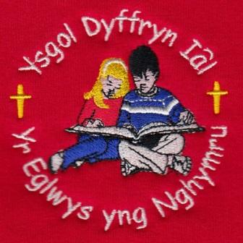
What have we been up to this week?
Dosbarth Tysilio – This week in Dosbarth Tysilio, we have been busy practicing for our Carol Service taking place next week in the church. In Literacy, we have been busy writing our own thoughtful questions for Father Christmas. We also explored the use of capital letters for names, places and special celebrations, helping us to improve our sentence accuracy. In Mathematics, our Reception children have been developing their counting skills, while Year 1 and Year 2 have been working on recording number facts and making links between addition and subtraction. As part of our Design and Technology learning, we investigated different types of levers and created our very own waving-hand Santas. We also enjoyed making festive Christmas decorations during our Forest School session with Mrs Williams.
Dosbarth Tecla Information provided by Myfi White of year 6 and Bonnie Smith of year 5. This week in Dosbarth Tecla we have been learning about “Scherenschnitt” which translates as paper cutting. We’ve learnt that the Danish author Hans Christian Andersen was famous for creating intricate paper cuttings as he told his stories. We have used this technique to create our Christmas cards this year. We have also been busy creating our own Christmas decorations; Julnisser. In maths year 3 have been grouping and sharing, year 4 multiplying and dividing, year 5 adding and subtracting fractions and year 6 have been finding a fraction of an amount. Criw Cymraeg had their meeting this week to evaluate our progress to achieving the Silver Award. They have been modelling Welsh games at playtime as well as planned a “Christmas Carousel” of activities for next week for Dosbarth Tecla. Mr Gareth Williams (Welsh Advisor) came to visit on Monday where he worked with groups of children on Welsh reading and oracy. He was impressed with their attitude and enthusiasm. We look forward to welcoming him back next week. Denbighshire music co-operative came to school and did a drums workshop with us, which was really fun. We have also been practising our scripts and singing for the Christmas Carol Service.

Christian Focus For
This Half Term

PEACE
FOYDI Events

Christmas hamper raffle in the Christmas Concert
12th December/ Rhagfyr 2025
Attendance – Our School Target is 95%
Attendance last week – whole school 90%, Dosbarth Tysilio 88%, Dosbarth Tecla 91.1%
Attendance for this term so far – 93.89%
Christmas Carol Service – On Wednesday 17th December at 1.30pm in St Tecla’s Church, Llandegla. There is no nursery session on this day. Nursery pupils are welcome to come to church to watch the service accompanied by a parent or guardian. We are kindly asking for donations this year, with it not being a ticketed concert, payments can be made via Parentpay. FOYDI will be selling raffle tickets to win a Christmas Hamper, which will be drawn at our Christmas Party on Friday 19th December.
Pantomime Trip – ‘Wizard of Oz’ at Stiwt Theatre in Rhos on Friday 19th December. We kindly ask parents to pay £5 per pupil to cover coach transport and interval ice cream via ParentPay by Wednesday 16th December Tickets and a huge transport contribution has been paid for by Friends of Ysgol Dyffryn Ial.
Christmas Party – On Friday 19th December nursery pupils are welcome to join us for party food and a party afterwards with a special visitor. Please arrive at the slightly later time of 1.15 pm
Dosbarth Tecla - All pupils he been given their choir robe to take home today. We would be very grateful if these could be washed, ironed, and returned to school on Monday so that we are fully prepared for our upcoming Carol Service. Thank you for your support.

Dates For Your Diary

17th December – Christmas Carol Service – St Tecla’s Church 1.30pm
19th December – Whole school trip to ‘Wizard of Oz’ pantomime at Stiwt Theatre, followed by Christmas Party in school
19th December – Break up for the Christmas holidays
6th January - Pupils return to school, Monday 5th January is a staff training day.

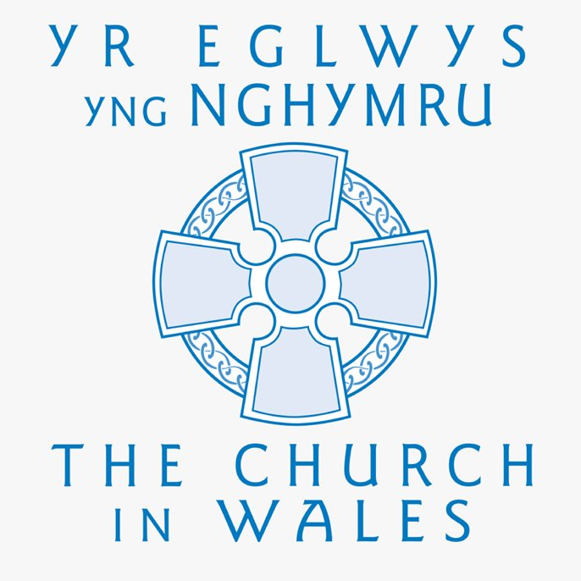

Safeguarding
If you have any safeguarding concerns, please contact one of our designated safeguarding leaders Mr Shaun Valentine, Mrs Ruth Barber or Mrs Sian Wilkinson on 01978 790645.

WINNING TEAM THIS WEEK
BERWYN

COMMUNITY
After School Club - A private After School Club is available in the Memorial Hall, contact Julie Tudor on 07984613534

Llythyr Newyddion Ysgol Dyffryn Iâl Newsletter
“We learn, We smile, We live, We dream together”

