Please can all children in the choir learn their words and practice as much as they can. Diolch
Dosbarth Tecla
- We have completed our information texts about the artist Giuseppe Acrimboldo as well as put his works of art in chronological order.
- In literacy we have been developing our dictionary skills and finding the meaning of some ambitious words which have been taken from our class book; James and the Giant Peach. We have enjoyed chapters 20-23 this week, in particular listening to the drama unfold for the earthworm who has been used for bait!
- We are continuing to learn our Welsh poem “Heini”. However, we have also began reading the story Wncwl Em o America and learning new vocabulary based on the story.
- In maths Bl3 worked on their 8 times tables, Bl4 were multiplying a 3 digit number by a 1 digit number, Bl5 were multiplying a 3 digit number by a 2 digit number and Bl6 were working on ratio and fractions.
Other News – Newyddion Arall
Dosbarth Tysilio
- We’ve enjoyed listening to the poem ‘My Stepdad is an Alien’
- Year 1 & 2 have been exploring the use of adjectives and adverbs.
- Reception have been recapping on all their letter sounds and blending simple words.
- In our mathematical work Reception have been exploring one less and creating their own number book, while Year 1 & 2 have been estimating numbers on a number line.
- In our topic work we have been exploring stars and constellations.
- We’ve created some lovely artwork inspired by Vincent Van Gogh’s Starry Night painting.

HUMILITY
Thank you to Llio from the Urdd who has delivered some great games over the past couple of weeks to develop the children’s Welsh vocabulary. A letter has gone home with the children this week with activities being held over half term.
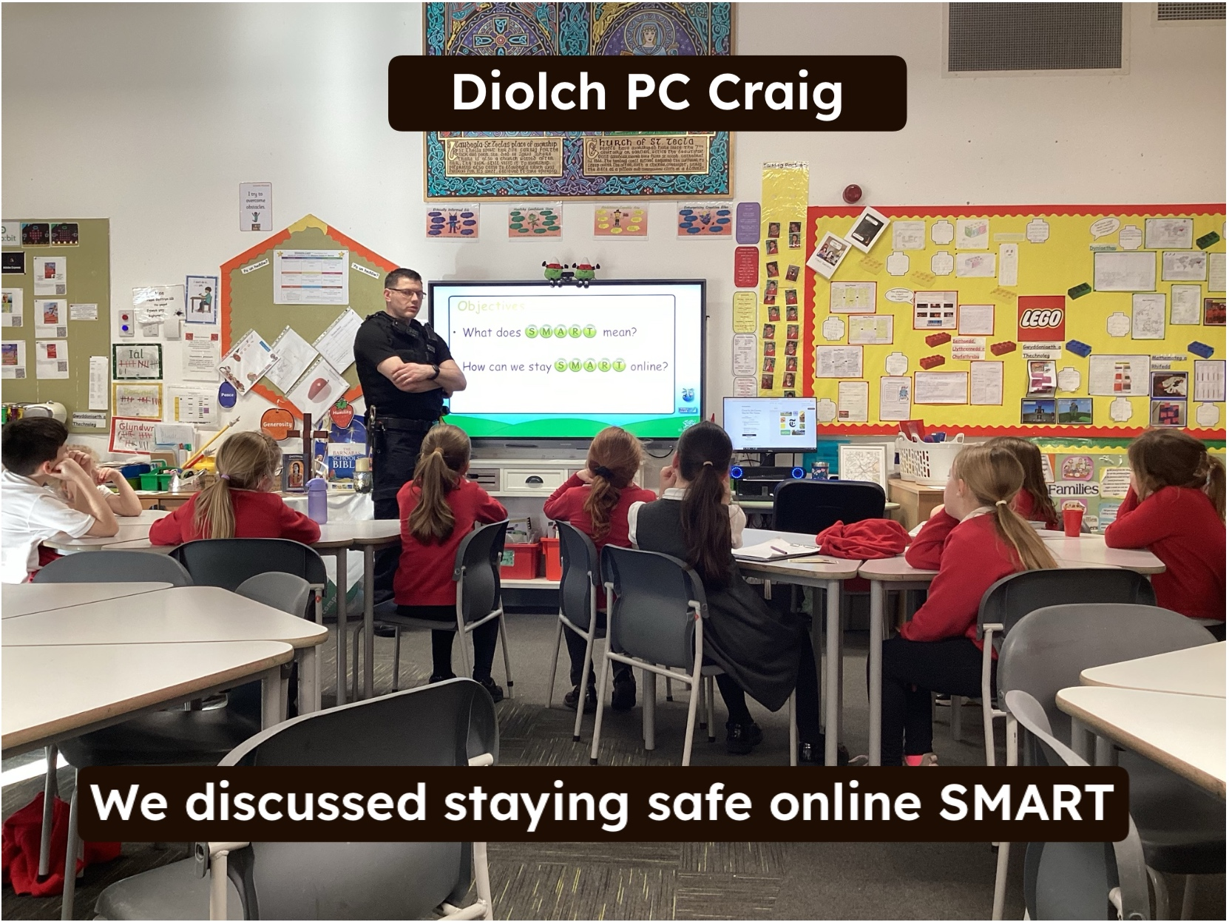
PC Craig delivered a ‘staying safe online’ workshop to Bl 3&4 and an ‘antisocial behaviour’ workshop to Bl 5&6. We look forward to welcoming PC Craig back in the spring term delivering more workshops to Dosbarth Tysilio & Dosbarth Tecla

PC Craig – Dosbarth Tecla



Attendance
School Target: 95%
Whole School Year to Date: 94%
Last Week: Dosbarth Tecla 98.6%
Dosbarth Tysilio 96.7%

Want to see more? Remember to connect to Seesaw
Website www.ysgoldyffrynial.co.uk for regular updates
After School Club
A private After School Club is available in the Memorial Hall Julie Tudor 07984613534

Winning Team
IAL

“Ga i help os gwelwch yn dda”
School Newsletter
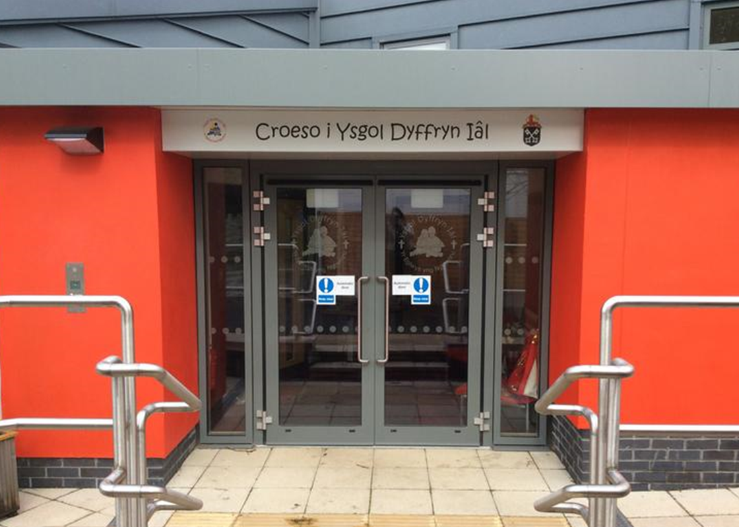
Safeguarding
If you have any safeguarding concerns, please contact one of our designated safeguarding leaders Mr Shaun Valentine, Mrs Ruth Barber or Mrs Sian Wilkinson on 01978 790645.

Dates for your Diary
- 5th February - Indoor athletics competition for Dosbarth Tecla in Myddelton College
- 13th February – Break up for half term
- 23rd February - Back to School

URDD


Christian Focus For This Half Term


Welsh Phrase of the Week
Class News – Newyddion Dosbarth
30ain Ionawr 2026
Ysgol Dyffryn Iâl



