Attendance
School Target: 95%
Whole School Year to Date: 93.9%
Last Week: Dosbarth Tecla 98.6%
Dosbarth Tysilio 91%

Forest School

Want to see more? Remember to connect to Seesaw
Website www.ysgoldyffrynial.co.uk for regular updates
After School Club
A private After School Club is available in the Memorial Hall Julie Tudor 07984613534

Winning Team
Glyndwr/Berwyn
Dosbarth Tysilio
- We have enjoyed listening to a selection of poems and choosing our favourite ones
- Reception have been recapping on their letters sounds ‘s, a, t, i, p’ and blending simple words
- In our mathematical work Reception have been adding one more, while Year 1 & 2 have been partitioning numbers into tens and ones
- In our topic work we have been exploring what lives on planet earth and collecting facts about the sun
- In Cymraeg we have been learning new vocabulary e.g. planed – planet, roced – rocket a
Thank you once again to Llio from the Urdd who has delivered some great ball games developing our Welsh vocabulary skills.

Dosbarth Tecla
- We’ve been busy revising the ‘gu’ sound this week and playing lots of interactive games.
- In literacy we’ve created a poster promoting the giant peach as well as discussed James’s emotions and how these change throughout the story.
- Da iawn to those who have been practicing the Welsh poem “Heini”. Don’t forget there is a recording of the poem being read aloud on seesaw in our “Cymraeg” folder.
- A huge thank you to Llio (Urdd) who visited us twice this week to support us with our Cymraeg Campus Award. It was great observing the children using their Welsh through games.
- In Maths Yr 3 have been multiplying & dividing by 4 & 8, Yr 4 have been multiplying a 2 digit number by a 1 digit number, Yr 5 have been multiplying a 2 digit number by a 2 digit number and Yr 6 have been working on ratio.
Humility to seek help
Diolch yn fawr i’r Criw Cymraeg am arwain gweithgareddau Santes Dwynwen heddiw. Huge thank you to Criw Cymraeg members for leading with our Santes Dwynwen activities. We also enjoyed watching a ‘Mewn Cymeriad’ video about Santes Dwynwen.
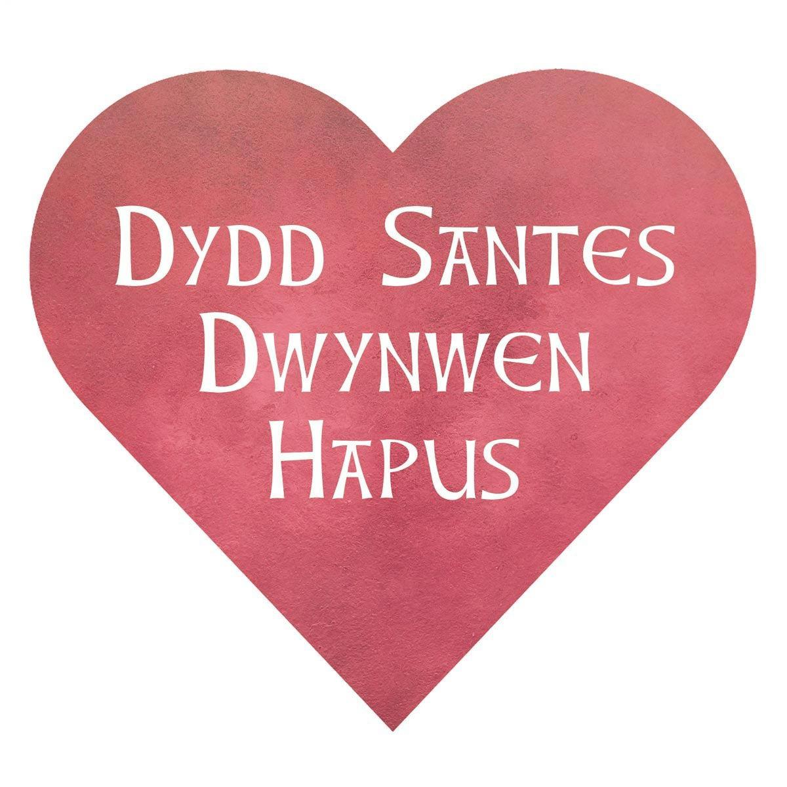
The children have been enjoying campfires during their forest school afternoons. If anyone has a couple of logs they could spare it would be much appreciated.

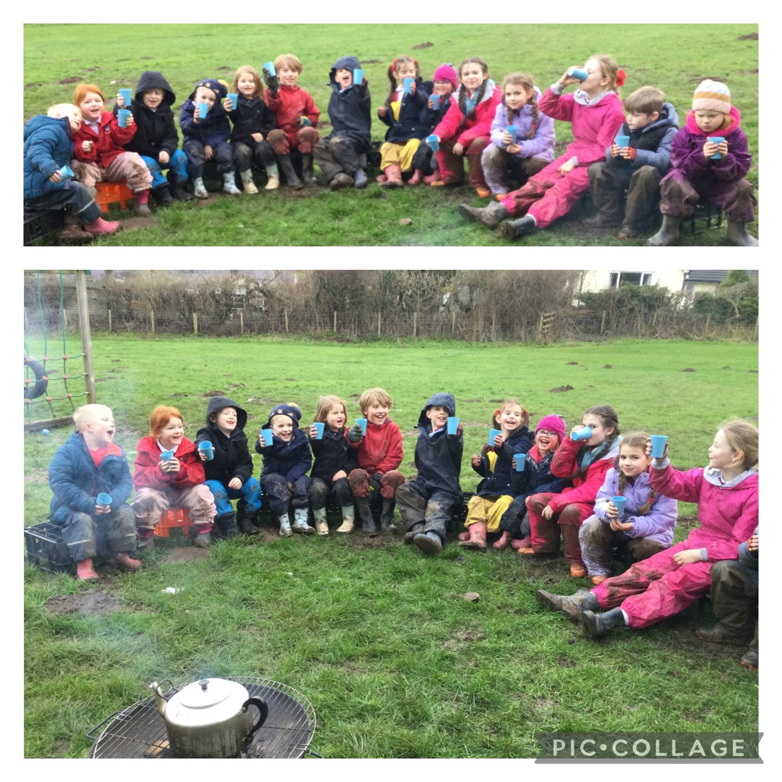
“Ga i fenthyg….. os gwelwch yn dda”
HUMILITY
School Newsletter
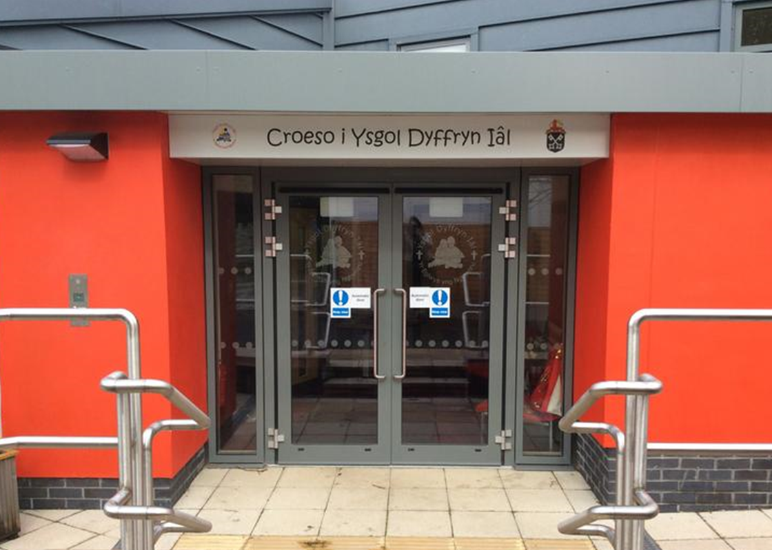
Safeguarding
If you have any safeguarding concerns, please contact one of our designated safeguarding leaders Mr Shaun Valentine, Mrs Ruth Barber or Mrs Sian Wilkinson on 01978 790645.

Dates for your Diary

29th & 30th January - Year 3 & 4 residential in Pentrellyncymer

5th February - Indoor athletics competition for Dosbarth Tecla in Myddelton College

13th February – Break up for half term

23rd February - Back to School

Dyddd Santes Dwynwen


Christian Focus For This Half Term


Welsh Phrase of the Week
Other News – Newyddion Arall
Class News – Newyddion Dosbarth
23ain Ionawr 2026
Ysgol Dyffryn Iâl



