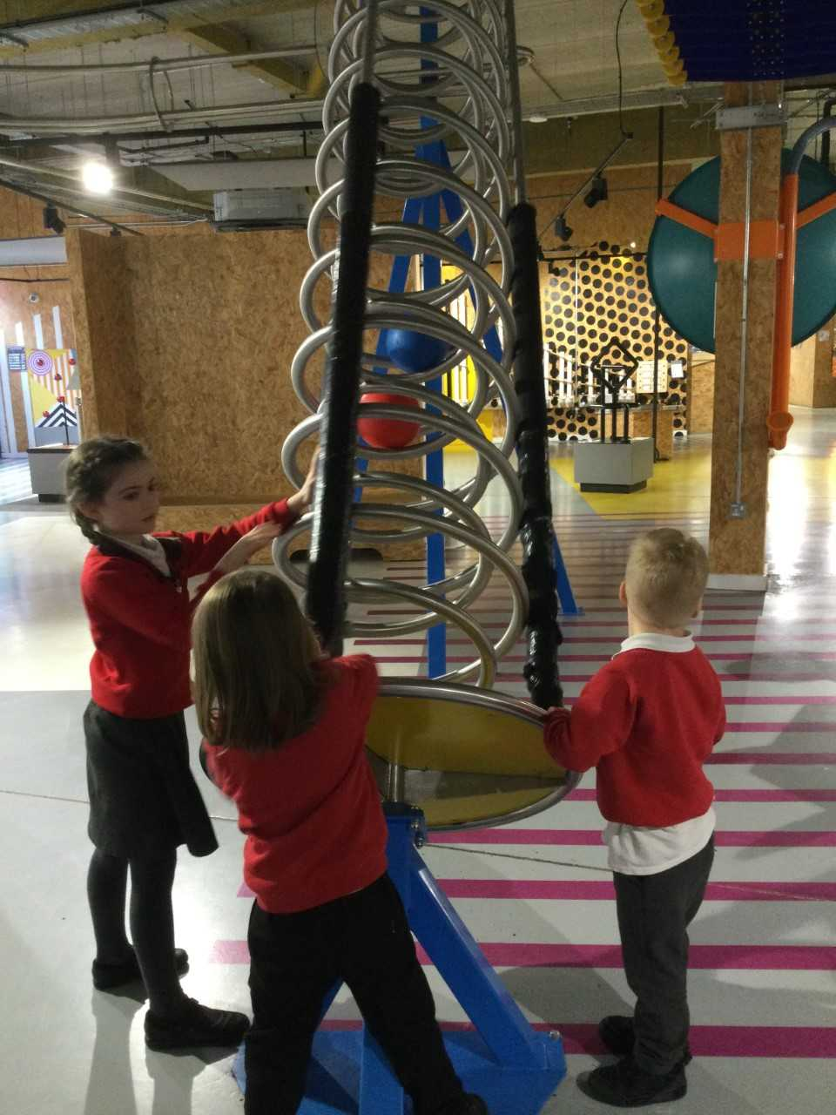
School Eisteddfod
We are looking forward to welcoming parents and family members to our School Eisteddfod on Tuesday 3rd March at 2pm in the Memorial Hall. Please can the children bring their competition entries in no later than 9am on Monday (cooking entries 9am Tuesday). Diolch!
27ain Chwefror 2026
Xplore
Dosbarth Tysilio have enjoyed a trip to ‘Xplore Science Discovery Centre’ this week to continue their work on ‘Space’. They participated in two workshops and got to explore the different activity stations.

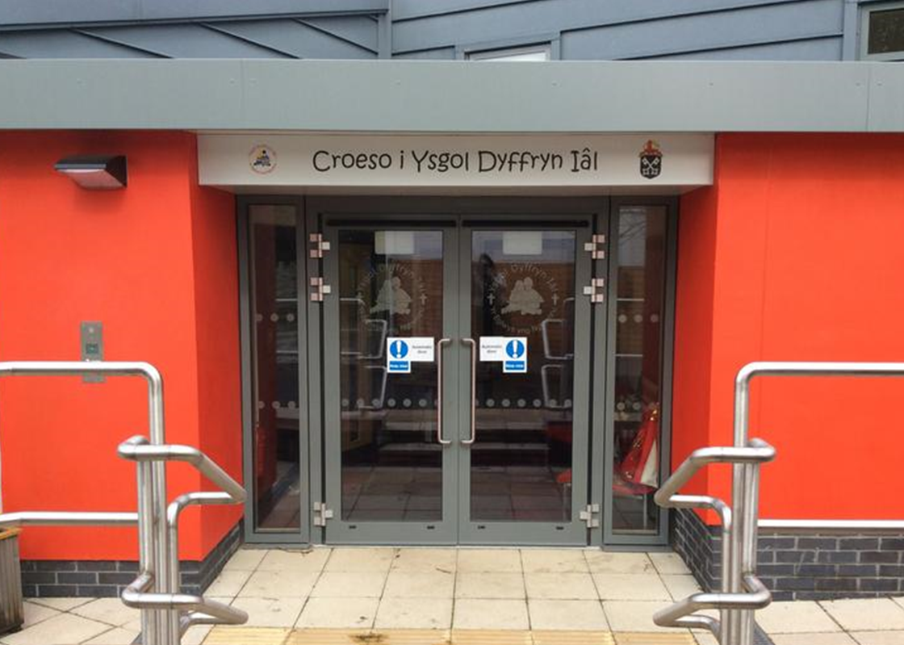
Dates for your Diary
- 3rd March – St David’s Day Eisteddfod at 2pm
- 4th March – DangerPoint Trip – Whole School
- 5th March – World book day-dress up as your favourite book character
- 9th March – Parents Evening Years 5 & 6
- 11th March – Parents Evening Dosbarth Tysilio & Years 3 & 4
- 18th March – ‘Come dine with me’ – Dosbarth Tysilio
- 19th March – Parents Evening Dosbarth Tysilio
- 24th March – ‘Come dine with me’ – Dosbarth Tecla
- 25th March - Easter Service – at St Tysilio’s Church Bryneglwys at 10am
- 27th March – FOYDI Movie night 3.15pm-5pm

Winning Team
GLYNDWR
Safeguarding
If you have any safeguarding concerns, please contact one of our designated safeguarding leaders Mr Shaun Valentine, Mrs Ruth Barber or Mrs Sian Wilkinson on 01978 790645.

“Ga i fynd i chwarae?”
After School Club
A private After School Club is available in the Memorial Hall Julie Tudor 07984613534

Dosbarth Tecla
- This week we have been busy completing a range of activities based on Dewi Sant. Bl 6 have been busy working together to retell his story in their own words.
- We have also been busy building his Monastery found in Llanddewibrefi in Minecraft.
- In Cymraeg we have been learning Welsh words and phrases based on the story of Dewi Sant through games like “Oes gen ti…?” and “Gem lŵp”.
- We also wrote a Welsh poem which we will read in our school Eisteddfod next week.
- In Maths Bl 3 have been multiplying & dividing, Bl 4 have been working on perimeter and equivalent distances, Bl 5 have been multiplying fractions by a whole number and Bl 6 have been writing form expressions in algebra.
Other News – Newyddion Arall
Dosbarth Tysilio
- We have been finding out all about the first moon landing.
- We have been creating our own aliens and used adjectives and adverbs to describe them.
- In our mathematical work Reception have been finding pairs and noticing odd numbers, while Year 1 and 2 have been looking at related number facts.
- We have been composing our own verses for the song ‘Pwy wnaeth y ser uwchben?’ as part of our creative work.
- We also had a very busy time visiting the science discovery centre ‘Xplore’.

HOPE

Attendance
School Target: 95%
Whole School Year to Date: 94.2%
Week Before Half Term: Dosbarth Tecla 92%
Dosbarth Tysilio 84%

Want to see more? Remember to connect to Seesaw
Website www.ysgoldyffrynial.co.uk for regular updates

School Newsletter


Christian Focus For This Half Term


Welsh Phrase of the Week
Class News – Newyddion Dosbarth
Ysgol Dyffryn Iâl



