We would like to thank FOYDI for their financial support, and fundraising events. Also, we would like to thank Lloyds Bank for matching one of the PTA members fundraisers/ volunteering hours totalling to £500. Diolch!!

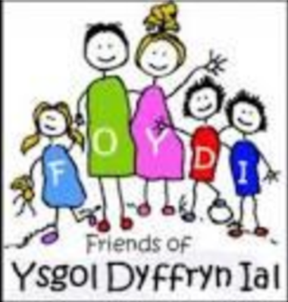
Dates for your Diary
- 25th February – Year 5 - Ysgol Brynhyfryd am only
- 26th February – Xplore trip - Dosbarth Tysilio
- 3rd March – St David’s Day Eisteddfod at 2pm
- 4th March – Dangerpoint Trip – Whole School
- 5th March – World book day
- 9th March – Parents Evening Years 5 & 6
- 11th March – Parents Evening Dosbarth Tysilio & Years 3 & 4
- 18th March – ‘Come dine with me’ – Dosbarth Tysilio
- 19th March – Parents Evening Dosbarth Tysilio
- 24th March – ‘Come dine with me’ – Dosbarth Tecla
- 25th March - Easter Service – at St Tysilio’s Church Bryneglwys at 10am

Winning Team
GLYNDWR
Safeguarding
If you have any safeguarding concerns, please contact one of our designated safeguarding leaders Mr Shaun Valentine, Mrs Ruth Barber or Mrs Sian Wilkinson on 01978 790645.

Craft Club
Beginning on Tuesday 24th February Mrs Barber
& Mrs Wilkinson will be holding a Craft Club
for pupils Year 1 to Year 6 until 4.15pm, this will continue every Tuesday until Easter.
Please can you email ysgol.dyffryn.ial@denbighshire.gov.uk to confirm your child’s attendance and commitment for the 5 weeks.
There will be no performing arts club on a Monday after half term, but this will begin again after Easter.

“Oes gen ti?”
After School Club
A private After School Club is available in the Memorial Hall Julie Tudor 07984613534

Dosbarth Tecla
- We have finished reading James and the Giant Peach! We really enjoyed reading the story together and discussing characters and events. A big thank you to those who volunteered to read aloud over the last few weeks; da iawn chi!
- We have enjoyed learning about and listening to some Welsh bands and artists this week in preparation for Diwrnod Miwsig Cymru. The Criw Cymraeg have created a graph showing which songs were our favourite.
- We joined other schools around Wales in a live assembly on internet safety. Then we participated in an Adobe live lesson all about internet safety where we created a…….
- In Maths Bl 3 are multiplying a 2 digit number by a 1 digit number, Bl 4 are dividing 2 & 3 digit numbers by a 1 digit number, Bl 5 are working on division with remainders and Bl 6 have started work on algebra.
Other News – Newyddion Arall
Dosbarth Tysilio
- We’ve been listening to the poem ‘The Spaceship with L-Plates and using rhyme to write our own rhyming couplets
- Reception have been learning their new letter sounds and blending words
- In our mathematical work Reception have been exploring one more, while Year 1 & 2 have been comparing numbers up to 100
- In our topic work we have been investigating reflective materials and how the moon reflects the sunlight
- We’ve had lots of fun celebrating ‘Dydd Miwsig Cymru’ and practicing our dawnsio gwerin

HUMILITY
Friends of Ysgol Dyffryn Ial

Attendance
School Target: 95%
Whole School Year to Date: 94.1%
Last Week: Dosbarth Tecla 99%
Dosbarth Tysilio 97%

Want to see more? Remember to connect to Seesaw
Website www.ysgoldyffrynial.co.uk for regular updates

School Newsletter
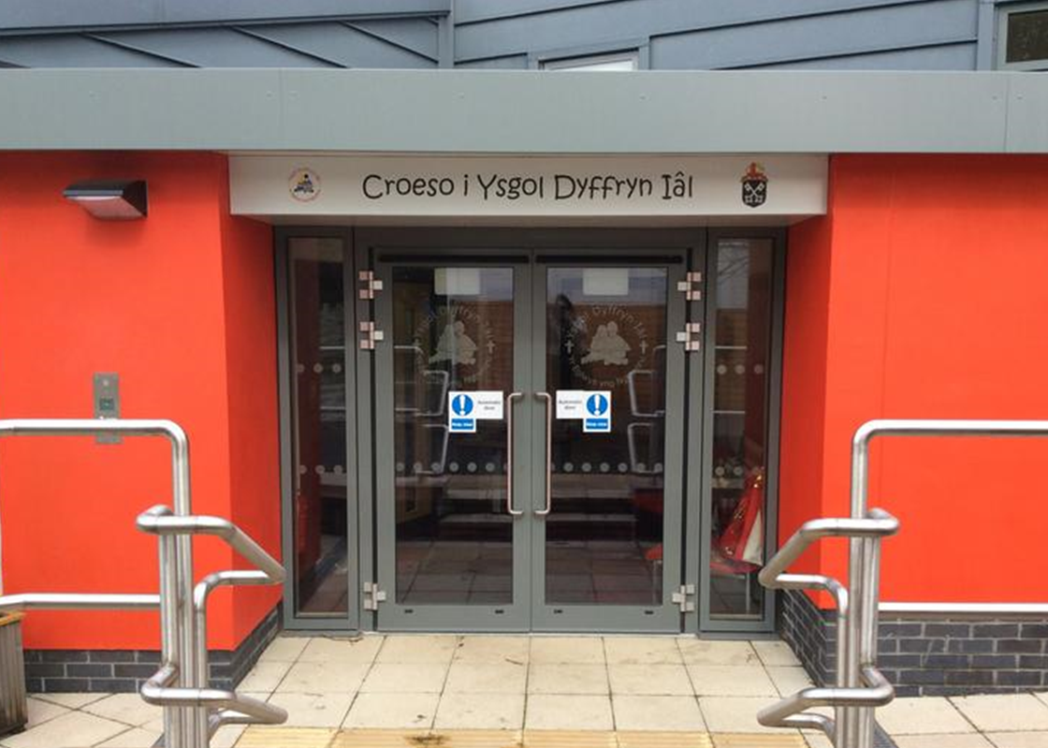


Christian Focus For This Half Term


Welsh Phrase of the Week
Class News – Newyddion Dosbarth
13eg Chwefror 2026
Ysgol Dyffryn Iâl



